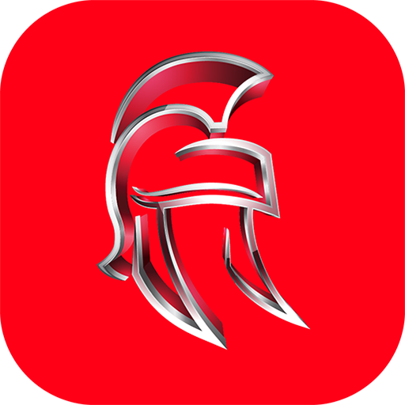

PRESS RELEASE

Max-a-Millions Challenge Zone – Play 3 Sports Challenges in one app and Win Cash Prizes !

Yes, you heard it right. A Mobile game with Big cash prizes? Don’t get confused, it’s not gambling. For all those Golf, Basketball, Soccer and mobile game enthusiasts, if you got the skills then play one of three challenge games in this single Max-a-Millions App.

For golf lovers, you have the Five Putt Challenge. For basketball fans, there’s a Free Throw Challenge and for Soccer crazy gamers, there’s the World Cup Challenge. Whichever, challenge you take, share monthly Leader-board Cash Prizes of £3000 and Three Big Annual Rolling Jackpot Prizes.

Max-a-Millions is the next generation sports entertainment mobile app with amazing visual graphics in Full HD with funky background music that pumps up the tempo to help you achieve more. The app gives players the option to practice for free, allowing every challenger the chance to reach their highest levels in every game and with the opportunity to win big cash prizes Max-a-Millions is the Global Leader in Competitive Entertainment Apps.

With the Max-a-Millions App, you can swing your putter; throw the Basketball with precision or kick a Soccer ball and make your way to the top of any 3 monthly Leader-boards. Every player has the opportunity to win and share in £3000 monthly cash prizes or play for one of our 3 Annual Rolling Jackpot Prizes , all this in a single App. Show your online game skills against challengers from around the Globe. Reach the top of the Leaderboards and win big cash prizes.

Flick balls to make a putt, sink a hoop or smash a target! You don’t have to beat the App, just the next player out there! With monthly payouts for each challenge, and annual jackpots to play for… now really is the time to “Rise to the Challenge”. With our Max-a-Millions App all challenges are games of skill and by competing you get the chance to win Monthly Cash Prizes or one of our Annual Jackpot Prizes .

With Annual Rolling Jackpots to play for, the sky’s the limit. As the Max-a-Millions challenge community grows, so does our Rolling Jackpot. So join us now, who knows, you could be on your way to becoming a Max-a-Millionaire! It’s flicking fun with the chance to win Big!

The Free app is available to download for Android and iPhones from Google Play and the App Store. Download now and challenge to win big.

iOS <https://goo.gl/UBAbAe>

ANDROID <https://goo.gl/4hAhSm>