Press Release

06/02/2018

Now Blue Planet II fans can test their natural history knowledge using the BBC Earth Quiz App
Available now from Google Play and the Apple App Store

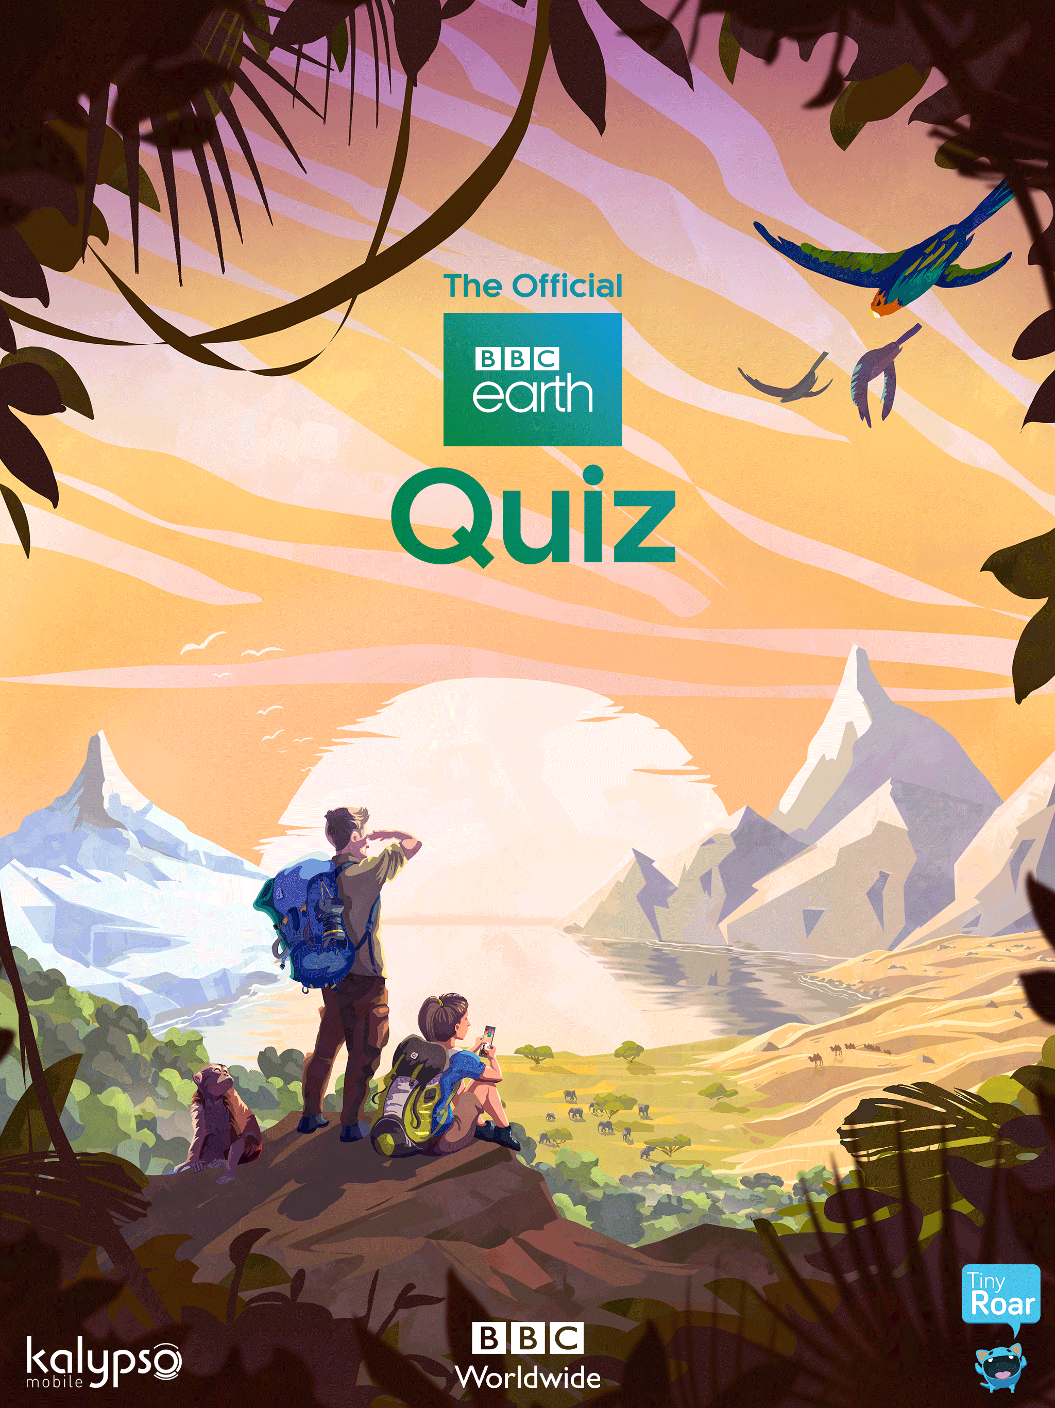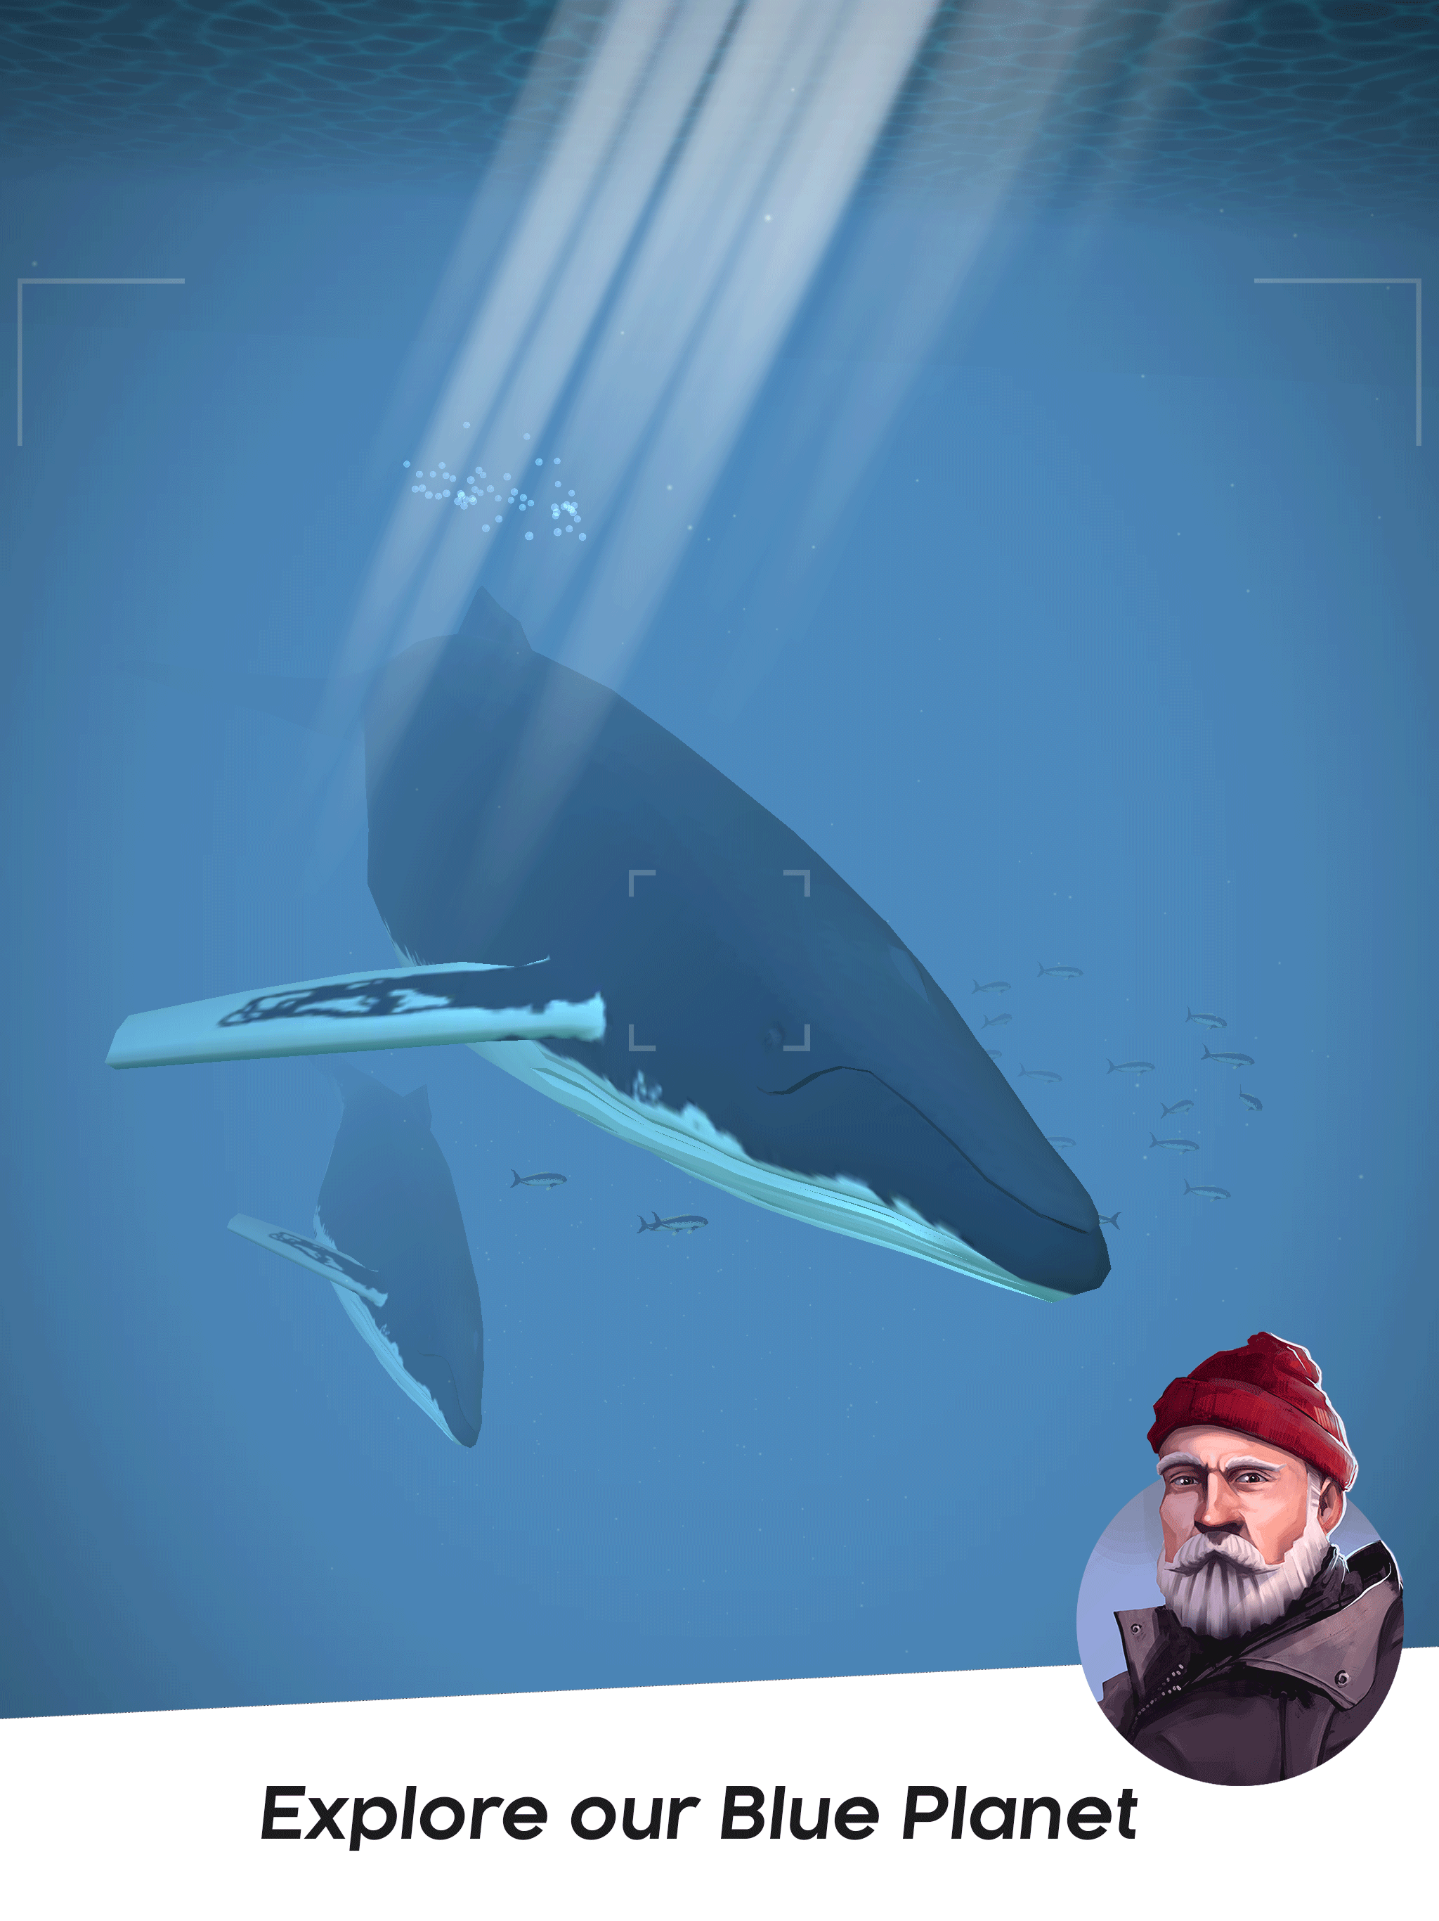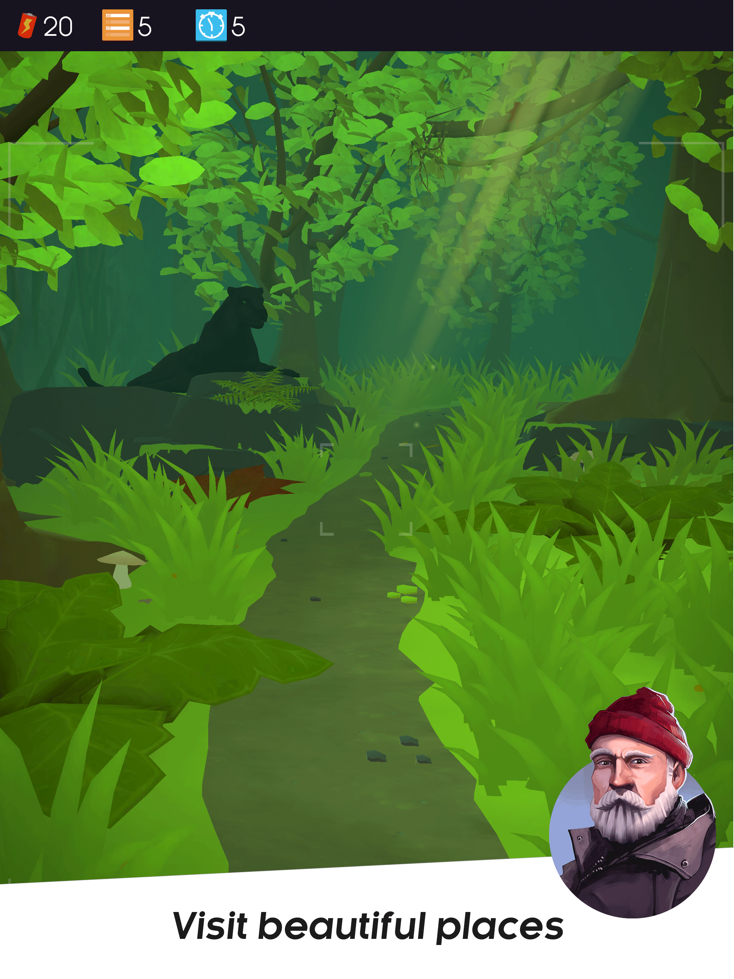

BBC Worldwide and games publisher and developer Kalypso Media have collaborated to produce a brand new natural history-themed mobile quiz game, The BBC Earth Quiz, featuring content from the hit series Blue Planet II, as well as other award-winning BBC natural history documentaries.

The app is free to download now from Google Play https://play.google.com/store/apps/details?id=com.kalypsomedia.bbcquiz and Apple’s App Store https://itunes.apple.com/app/id1218239849.

Blue Planet II was the UK’s most-viewed television show of 2017 and is now being enjoyed by millions of viewers around the world.

The BBC Earth Quiz includes over 4000 questions and clips drawn from the BBC’s critically acclaimed and hugely popular natural history series including Planet Earth, Planet Earth II, Life, Africa and The Blue Planet and Blue Planet II.

The quiz is designed for people of all ages to enjoy, testing the natural history knowledge of beginners through to budding naturalists. Players are cast in the role of a photographer travelling across eight different environments, including arid deserts, sweeping grasslands, dense jungles and the deepest oceans. They compete against an AI opponent to answer questions related to the environment that they are in, all against the clock. Each correct answer unlocks content from the BBC’s extensive natural history archive. Once the player has managed to unlock all the content from one environment, they are then able to progress to the next.
Players can opt for extra time to think of an answer, or choose 50/50, where two of the incorrect answers are removed. It’s also possible to take part in a global head-to-head multiplayer mode. The winner is the person with the most correct answers when the time runs out.

Bradley Crooks, Head of Digital Entertainment and Games at BBC Worldwide said
“BBC Worldwide is pleased to have partnered with Kalypso Media, a renowned name in the games industry, who have a track record of producing high quality interactive titles. The BBC Earth Quiz showcases the richness of the BBC’s natural history content and provides fans of all ages with a vibrant and educational experience.”

Marcus Behrens, Publishing Director of Mobile at Kalypso Media said ”We’re excited to have created a game based on such an iconic property. The BBC is known as the world leader in natural history programming, which have over the years been enjoyed and loved by millions. We have created a quality educational experience that provides fans with exciting new ways of interacting with this incredible content.”

The BBC Earth Quiz will be continually updated with additional content including in-game events, competitions, worlds and questions and is free to download now from Google Play https://play.google.com/store/apps/details?id=com.kalypsomedia.bbcquiz and the Apple App Store https://itunes.apple.com/app/id1218239849.

Access the BBC Earth Quiz App press kit here: https://drive.google.com/drive/folders/14MGeVfyGEKquhMuLLLNBaiRLryRsEf0f?usp=sharing

-Ends-

For more information, please contact:
Dan Phelan, Head of Communications, UK
BBC Worldwide
dan.phelan@bbc.com
@BBCWorldwide_UK

Theo Tsangaris - theo@biggamesmachine.com
TEL: +44 (0) 203 637 4244
Big Games Machine - www.biggamesmachine.com

NOTES TO EDITORS

About BBC Worldwide
BBC Worldwide is a principal commercial arm and a wholly owned subsidiary of the British Broadcasting Corporation (BBC). Its vision is to build the BBC’s brands, audiences, commercial returns and reputation across the world. This is achieved through investing in, commercialising and showcasing content from the BBC around the world, in a way that is consistent with BBC standards and values. The business also champions British creativity globally.

In 2016/17 BBC Worldwide generated headline profits of £157.3 and headline sales of £1,059.9m and returned £210.5m to the BBC.

For more detailed performance information please see our Annual Review webpage: bbcworldwide.com/annual-review

bbcworldwide.com
twitter.com/bbcwpress

About The Kalypso Media Group
Celebrating its 12th year in the video games industry, the Kalypso Media Group is a privately owned, global, independent developer, marketer and publisher of interactive entertainment software with close to 100 employees worldwide, operating from seven offices across Germany, the United Kingdom and the United States. Kalypso Media has also established a digital-first label called “Kasedo Games” and enjoys very strong global digital distribution through its Kalypso Media Digital subsidiary. Furthermore, the group owns two development studios – Realmforge and Gaming Minds– to secure a constant supply of high quality games, and works with multiple leading independent developers. In 2015, Kalypso Media Mobile was founded in Hamburg, Germany, to deliver great games for mobile devices. Kalypso Media‘s titles include the critically acclaimed “Tropico” series, strong strategy game franchises like “Dungeons”, “Port Royale” and “Sudden Strike”, as well as action RPG games such as “Vikings – Wolves of Midgard”, among others. For 2018, “Railway Empire”, “Shadows: Awakening” and “Tropico 6” have been announced for all major platforms (PC, Xbox One, PS4). Moreover, Kasedo Games has signed “Rise of Industry” for digital distribution and Kalypso Mobile will release “Ski Jumping Pro” on all mobile devices and “Project Highrise” for tablet devices.

More information about the Kalypso Media Group is available at www.kalypsomedia.com

