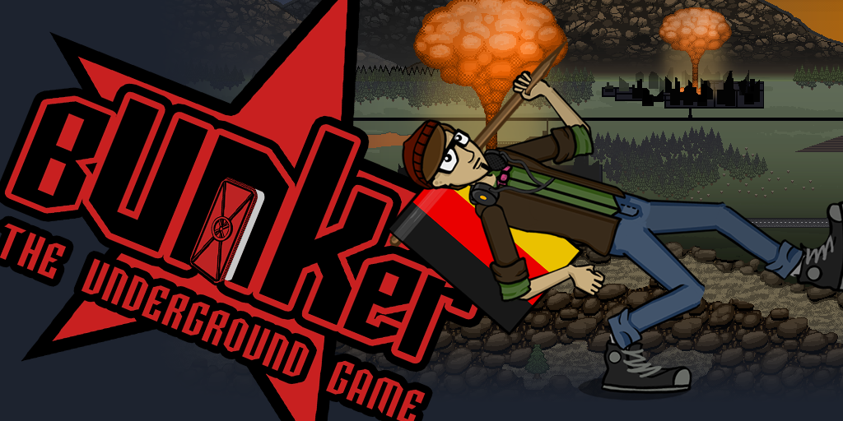

Bunker - The Underground Game. The Indie Point & Click adventure available on Steam has just been updated with massive patch together with the new lower price. Better and cheaper than ever you can experience the surprise infused Soviet mystery just for $ 9.99! Play it in English or German.

Take a stumble down the stairs of adventure and hit your head with the puzzles that'll blast your brains into the past. A spontaneous rap-battle in middle of Moscow between a hamster and dolphin is insufficient to explain how awesome Bunker is, you'll need to experience it yourself. Sure you could watch one of the many LetsPlays surfacing the web and sure you could use walkthrough, but how about you play this one yourself? How about you actually beat and find all of the 33 super secret & authentic achievements withouth strategy guide? Can you do it, can you be one of the 3% of players that actually managed to pull that off? Well you don't need to, just saying...

Game's website www.bunkerthegame.com
For the press: http://www.bunkerthegame.com/press.html


Contact us if you wish to arrange an interview or something special for your news article. We are happy to assist with any editorial needs.
Contact us for the Steam review keys at:
nightlystudios@gmail.com or pr@2tainment.com

