True-story adventure game Cosmic Top Secret out now on Steam and Mobile
Award-winning game created by the daughter of Danish Cold-War spies features real audio interviews as well as video footage and documents from the era

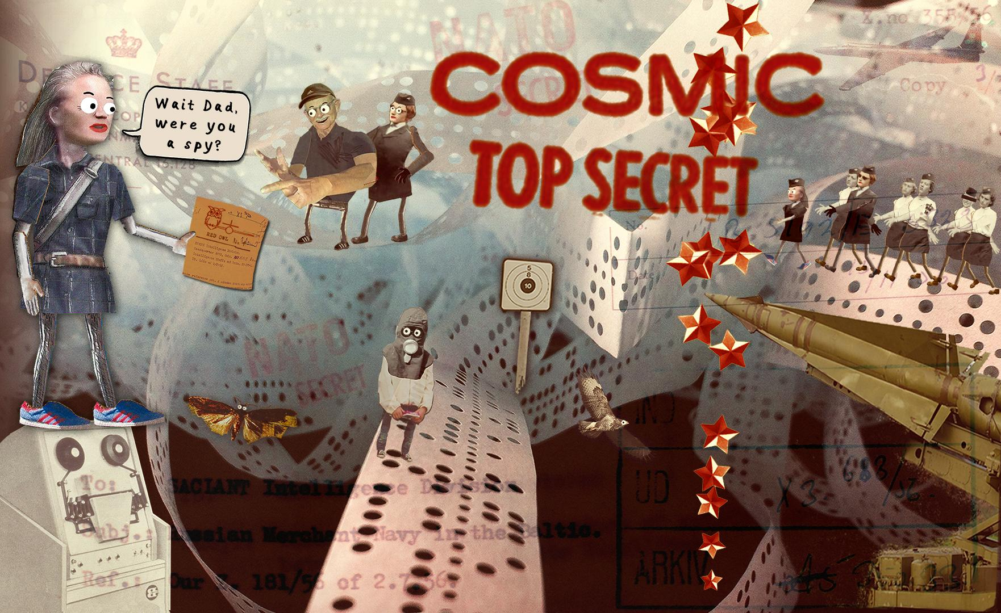

COSMIC TOP SECRET (CTS) - This security classification is applied to information the unauthorized disclosure of which would cause exceptionally grave damage to NATO (NATO is an acronym for the North Atlantic Treaty Organization)

15 November 2018, Copenhagen, Denmark – Independent game studio Those Eyes and film studio Klassefilm today announced that its true-story adventure game Cosmic Top Secret is now available for download on PC and mobile. Best described as a hybrid of reality and fantasy told in an abstract papercraft world, Cosmic Top Secret has been seven years in the making. The game tells the incredible true-life story of ‘T’ (Trine, the game’s lead developer) and her journey to discover more about her parent’s involvement with the Danish Intelligence Service during the Cold War.

As part of the game’s production, Trine interviewed her parents and their former colleagues for 7 years, building a portfolio of over 100 hours of video and audio footage. The game’s dedication to accurately depicting Cold War events is such that Trine arranged meetings at the Headquarters of the Danish Military Intelligence to secure clearance on the use of the interviews and certain documents within the game.

In Cosmic Top Secret, players flick, roll and glide their way across six distinct levels, uncovering clues and completing secret dossiers by gathering over 400 collectables. Along the way, players meet a cast of colourful and unforgettable characters including Queen Margrethe II of Denmark. The title has already won 3 prestigious awards for storytelling and game quality at high-profile events including AMaze Berlin, IndieCade LA and IDFA DocLab 2017. Cosmic Top Secret was also a finalist for this year's prestigious Indie Game Festival’s Nuovo Award – an award that recognises distinctly artistic titles.

Cosmic Top Secret aims to bridge space between video games and documentaries by defining itself as a “Docu-game” that will appeal to any gamer. Core video game players will welcome the traditional interactive video game elements including puzzles, challenges, map navigation and interaction with other characters while less-seasoned gamers can enjoy the game’s rich narrative based on documents, audio and video relating to the Cold War era.

The game’s original soundtrack was also composed by Danish musician Bjørn Svin, whose tracks have had thousands of streams across all significant streaming platforms.

Cosmic Top Secret is available on Steam at: https://store.steampowered.com/app/785100/Cosmic_Top_Secret/

Cosmic Top Secret is available as a premium app on the App Store at:
https://itunes.apple.com/tr/app/cosmic-top-secret/id1005498745

Cosmic Top Secret is available as a premium app on Google Play at: https://play.google.com/store/apps/details?id=tv.laier.Cosmic

-------Ends-------

Notes to Editors
Press kit: http://www.cosmictopsecretgame.com/press

Twitter: https://twitter.com/invertedmatrix

Facebook: https://www.facebook.com/cosmictopsecret/

Website: http://www.cosmictopsecretgame.com/

For more information, please contact:
Theo Tsangaris - theo@bigideasmachine.com
TEL: +44 (0) 203 637 4244
Big Games Machine - http://www.biggamesmachine.com

About Klassefilm
Producer of documentary films for 15 years. And games since 2009. Owned by Emmy-nominated producer, Lise Saxtrup, producer of Cosmic Top Secret. We are highly interested in the encounters that art and media can form between and among people, creating spaces for reflection and transformation.

About Those Eyes
Those Eyes develops video games, art, film and animation in all kind of formats. The company was established in 1998 by game director Trine Laier and operates with sincerity, play and humor - and always with the aim to entertain and break new grounds for storytelling.

Cosmic Top Secret is directed and co-produced by Trine Laier, Those Eyes and produced by Lise Saxtrup, Klassefilm. It premieres November 15th (Danish, English and Italian version) in App Store, Google Play, STEAM, Humble Bundle and Green Man Gaming. The game has been featured and awarded at several movie festivals and game festivals winning “Most Amazing Game”, AMaze, Berlin 2016, ”Culture Prize”, IndieCade LA 2017 and “Award for Digital Storytelling”, IDFA DocLab 2017.

Cosmic Top Secret has received financial support from the Danish Film Institute, Creative Europe, Nordic Game, the Danish Animation Society and the Danish Art Foundation.

