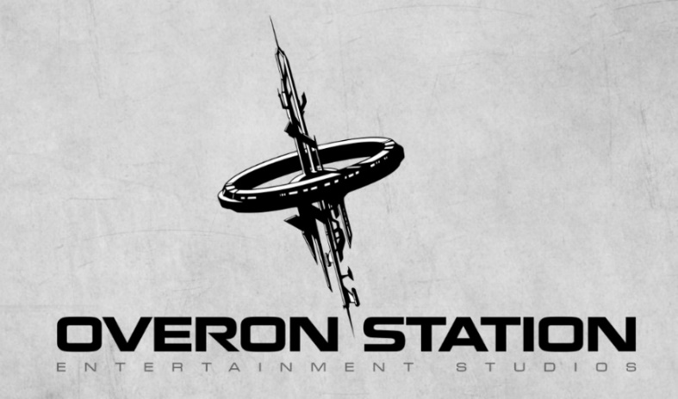

**​​First game from Overon Station with PETRI ALANKO on board - Dome City announcement**

*Imagine being stuck in an abandoned dome city on Mars as a young astronaut... lacking experiences, hardly any knowledge about space life, no visible way out... how would you survive?*

**Budapest, Hungary - Thursday 24th September, 2015** - With our first game, **Dome City**, based on István Nemere’s novel, we would like to invite you to a fun, mind-bending experience on Mars, which will get you lost in the maze of subtle riddles and unresolved mysteries. The story- and choice-oriented game powered by Unreal 4 Engine follows three young astronauts on their very first mission which soon takes a sudden turn when they get stuck in a Martian dome city.  Due to the first person view you can easily identify yourself with the guys whilst they try to find their way out by solving the puzzles and unravel the hidden secrets of the deserted area.

Our first trailer is just a short teaser, but it’s enough to sense the atmosphere and the contrast between the hypermodern spaceship and the outdated, rusty buildings in the city. You can have a look at it here:<https://youtu.be/rxcMquHIvHI>

Soon we’ll release our gameplay video as well, stay tuned!

**Soundtrack**

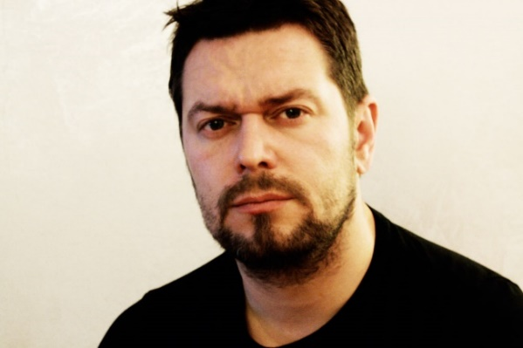Among a few truly talented Hungarian musicians we’re honored to have **Petri Alanko** on board with his wonderful music for the game. The Finnish composer, renowned for creating **Alan Wake** and **Trials Fusion** soundtracks, has already begun working on the first scores and the team can’t wait to share the wonderful melodies with the audience.

*“We’re really proud to come to terms with Petri. Alan Wake’s soundtrack is absolutely stunning and we’re sure he’ll compose equally excellent songs for us,”* said Csaba Királyházi, Managing Director of Overon Station.

You can download the **press kit** from here: <http://overonstation.com/index.php/press-kit/>

For more information please visit [www.overonstation.com](http://www.domecity.com), [facebook/DomeCityGame](https://www.facebook.com/domecitygame) or twitter [@DomeCityGame](http://twitter.com/DomeCityGame)

**About Overon Station**

Overon Station Entertainment Studios was formed in September, 2014 with a goal of making story-oriented video games which can be enjoyed by all. Our team is located in Hungary; it’s small yet really enthusiastic, coming from various professional backgrounds.

With the great artists, composers and writers we’re cooperating with, the main focus is on galvanizing life into exceptional stories that aren’t well known yet.

**Contact**

For any other questions, comments, please contact me at [pr@overonstation.com](mailto:pr@overonstation.com)!

Yours sincerely,

*Renata KISS*

**PR Manager**

[pr@overonstation.com](mailto:pr@overonstation.com)

[www.overonstation.com](http://www.overonstation.com)