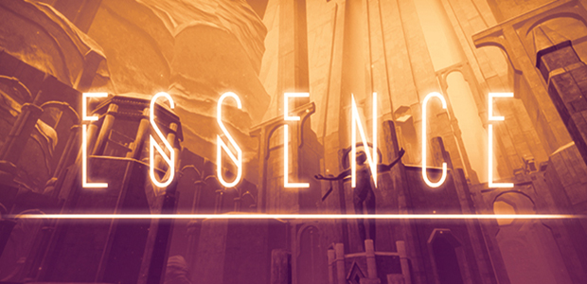

Hi there,

our game ESSENCE will launch on the 18th of April in Early Access and we want you to be part of it.

Starting today (12th of April), the beta of the first Act of ESSENCE is available for our Kickstarter backers and the press.

Please contact us if you are looking for Steam keys: pr@onevisiongames.com

(for news | reviews | previews | videos | streams )

More information about ESSENCE can be found on the following websites:

General Information: <http://www.onevisiongames.com/essencegame/>

Image material: <http://www.onevisiongames.com/press/>

Steam page: <http://store.steampowered.com/app/482440/>

Feel free to contact us any time.

All the best,

Tim & Ck from ONEVISION

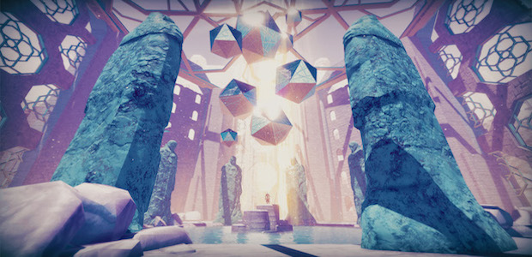

PRESS RELEASE:

ESSENCE LAUNCH DATE ANNOUNCED

Berlin, Germany; April 12, 2017 – The world of ESSENCE, forgotten by time and space, is emerging out of the gloom and unfolding its branches towards the sun.

It is reaching for you. It is reaching to be explored. It is reaching to unravel its secrets, to let you see beneath its beautiful surface.

It has been waiting for you. It has been waiting to show you what it has been and what it is going to be. It has been waiting, in order to present its thrilling adventures, inspiring landscapes, the thoughts of another dimension and a secret which darkens the truth about the world of ESSENCE like a veil.

It has been waiting, for almost 2 years now, which is the time the game developers of ONEVISION Games, took for the conception and development of their surreal exploration game ESSENCE.

Today, ONEVISION Games, did not only launch the long awaited, exclusive beta of ESSENCE, but also announced the official launch of the first act of three acts to be on the **18th of April 2017**.

Beside the launch date the two students behind ONEVISION Games also officially confirmed their plans to bring their debut game to Xbox One and PlayStation 4. Furthermore, they gave more information about the planned and strongly anticipated VR support of ESSENCE.

“A VR version of ESSENCE will be available with the launch of the third act. We are already working on optimizing the worlds of ESSENCE in order to make our huge landscapes VR Ready”, said Tim Bachmann, co-founders of ONEVISION Games.

Contact:

Tim Bachmann

[+4915757359757](tel:+49%201575%207359757)

[OneVisionGames@gmail.com](mailto:OneVisionGames@gmail.com)

[PR@OneVisionGames.com](mailto:PR@OneVisionGames.com)