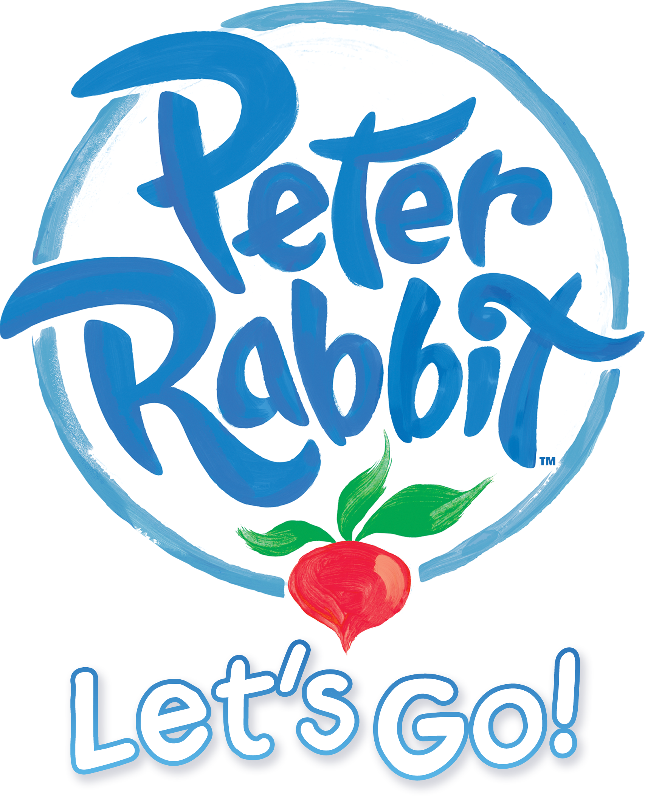

Peter Rabbit™ hops onto mobile in Peter Rabbit™: Let’s Go!

Charming adventure game based on the popular animated TV series watched by millions comes to iOS & Android.

20th June 2018, London, England – Independent game developer No Yetis Allowed today announced that its new mobile game Peter Rabbit: Let’s Go! is now available for download on The App Store and Google Play. Based on the popular Peter Rabbit global animated TV series, Peter Rabbit: Let’s Go! brings the Beatrix Potter favourite and his friends to life using vibrant 3D graphics and will surprise and delight young fans of the TV series. Packed with features, the game enables parents and children to spend time together exploring and interacting with the magical world of Peter Rabbit and his friends. Developer No Yetis Allowed also developed smash hit Pocket Shrek that had over 6.5 million downloads.

The app has been developed in association with Penguin Ventures (part of Penguin Random House), brand owners for Peter Rabbit and brokered by Silvergate Media, licensing agent for Peter Rabbit animation on behalf of Penguin Ventures.

Thomas Merrington, Creative Director for Penguin Ventures (part of Penguin Random House) said “In Peter Rabbit: Let’s Go! No Yetis Allowed have enabled fans of Peter Rabbit and his friends to engage with these much-loved characters in an entirely new way. We’re thrilled with the innovation and incredible 3D graphics which combined, will offer our young audience a brilliantly immersive experience.”

In the game, children join Peter and his friends Benjamin and Lily in their search for the pages of Peter’s dad’s lost journal. Along the way, children can explore a multitude of iconic landmarks and locations including Mr McGregor’s Garden, Mr Tod’s house, and Peter Rabbit’s home. Interactive activities include fun spelling games, music tasks, number challenges and creative picture colouring for hours of endless entertainment. Games include:

- Vegetable raids in Mr McGregor’s garden
- Pinecone bowling at the Squirrel Camp
- Ladybird hunting (watch out for the bees!)
- Strawberry raids at Mr Tod’s house
- Shape-matching games outside Peter Rabbit’s home
- Jeremy Fisher’s musical game
- Lift, bounce and throw blocks around Peter Rabbit’s home
- Balloon bouncing and bursting fun up in the secret treehouse
- Have fun with a toy train in Peter Rabbit’s bedroom
Peter Rabbit: Let’s Go! aims to give fans of the Peter Rabbit TV series the most authentic experience possible. This includes the use of lifelike animations and stunning high-quality 3D graphics that mirror the art style of the hit TV show, as well as the use of the original voice talent, bringing the personality of each character to life. Players can also tap and swipe characters to trigger dialogue options and animations – or tickle them just for fun!

Peter Rabbit: Let’s Go! features no in-app purchases or adverts, meaning parents can let their child play without the fear of additional payments. Plenty of additional content is planned post-launch, including mini-games such as Mr Bouncer’s target practice and more.

Download Peter Rabbit: Let’s Go! from the App Store:
https://itunes.apple.com/app/peter-rabbit-lets-go/id1340340619

Download Peter Rabbit: Let’s Go! from the Google Play Store:
https://play.google.com/store/apps/details?id=com.NoYetisAllowed.PeterRabbit

----- Ends -----
Notes to Editors

Press kit: https://drive.google.com/drive/folders/13SRVGvzTKX_jxSDvQhNxdEAnKtjvcp3j?usp=sharing

For more information please contact:

Theo Tsangaris - theo@biggamesmachine.com
TEL: +44 (0) 203 637 4244
Big Games Machine - www.biggamesmachine.com

About No Yetis Allowed
No Yetis Allowed was formed in 2013 by Mark Hardisty and Tom Weston with a view to bringing a console-quality mentality to the mobile space, using high-profile and much-loved character licenses.

About Peter Rabbit Animation
The Tale of Peter Rabbit by Beatrix Potter was first published in 1901, and has never been out of print since. Over the course of its 110-year history, it has sold more than 250 million copies, been translated into 35 different languages, and led to one of the world’s oldest licensed product ranges.

In partnership with co-producers Nickelodeon and publishers Frederick Warne, Silvergate has developed Peter Rabbit into a new 3D Computer-generated imagery (CGI) animated TV series for preschoolers. The animation is an inspiring and playful re-imagining of Beatrix Potter’s timeless children’s classic. Mischievous, charming and brave, Peter is a hero who overcomes obstacles, outwits predators and avoids danger as he embarks on a series of exciting adventures with his best friends Benjamin and Lily.

About Penguin Ventures
Stories have always been at the heart of Penguin Random House. Penguin Ventures was created to bring together the Licensing, Consumer Products, TV Production, Retail, Exhibitions and Live events strategies and to find new ways to tell the world’s favourite stories. Penguin Ventures manages a portfolio of licensed literary brands and characters together with an archive of original art. For many years, those characters lived mainly in books, but now they are providing the magic and wonder for all kinds of different consumer products, media and experiences, going beyond the book to tell the complete story.

About Silvergate Media
Silvergate Media is a creative content and licensing company driven by big ideas and big collaborations. Silvergate was formed in 2011 by Waheed Alli and William Astor, with offices in New York and London. In April 2016 Silvergate partnered with Shamrock Capital, an LA based private equity firm, who now hold a stake in the Company.

Silvergate develops and produces world-class content built to inspire, entertain and engage audiences of all ages through innovative storytelling, great products and strong partnerships.

PETER RABBIT™& © Copyright Frederick Warne & Co. Limited and Silvergate PPL Limited, 2018. Based on the works of Beatrix Potter. PETER RABBIT and BEATRIX POTTER are trademarks of Frederick Warne & Co, a Penguin Random House company. Licensed by Silvergate PPL. All rights reserved.

