**Tik Tak Toe Free Updated by SA Apps(Ahmed Kabir)**

Tik Tak Toe Free now Presented with Nine '9' different languages support.

Sep 11th 2015, Karachi, Pakistan SA Apps updates its best free Board Game for Android in a Press Meeting with their Founder SAK aka Syed Ahmed Kabir unveiling Awesomeness Tik Tak Toe Free by SA Apps updated to next version. Marvelous job done!!

"After awaiting a bit Here we go Tik Tak Toe Free now Presented with Nine '9' different languages support, Arabic, Chinese, French, German, Italian, Portuguese, Russian, Spanish and English"

said Ahmed, announcing an update by SA Apps officially, “Tik Tak Toe Free is developed to provide addicting fun and as an engaging challenging game to play against computer and other human users.”

Hand over to your friend or partner on their turn to play with them.

**What's new in this version?**

**Bugs Fixed:**

*After an audit of our app, we have observed what users loved, found out what they didn’t. So we have already fixed some minor bugs in this update, that were reported within previous versions of this game

**Beautiful Skins Added:**

** 30 awesome skins added in this version. with 5 available by default.

More skins can be installed by purchasing them from Shop option from main menu. Ads can also be removed now so play game smoothly without any ads if you opt for removing them via small in-app.

**Multilingual Support:**

* Localized for our great users and friends who have been insisting us to design and develop user interface as well as skins and all other options available in their own languages Great news for all of them...

Tik Tak Toe Free game is now available and supporting 9 different languages, e.g. Arabic, Chinese, French, German, Italian, Portuguese, Russian and Spanish along with English.

**\*\* User Feedback Appreciated:**

Please feel free to tell us what you like and don’t like about this recently updated version of our best free board game yet developed.

* If you love our game please rate it and share with friends to let them enjoy the board too.

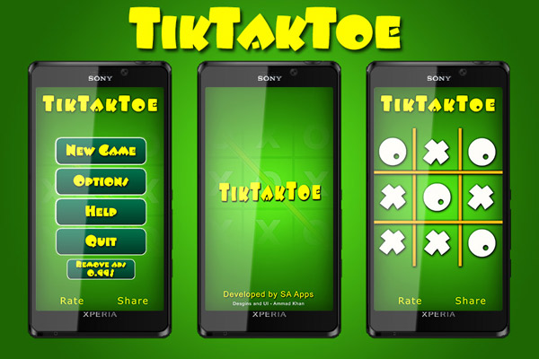

Previous users Update please and New one must have it to Enjoy the Best Free Board game for Android ever . . .

Download at Google Pay: play.google.com/store/apps/details?id=com.app.tiktaktoefree

**Website: saapps.net | Facebook: fb.com/SAAppsOfficial |Twitter: @SAAppsOfficial**

**Google Plus: Google.com/+SAAppsOfficial**

**Linkedin: linkedin.com/in/SAAppsOfficial**

#####