Army of Sloths

Overview:

Army of Sloths is a game designed by DoubLLe Games that puts you in the center of a battle for survival. As I’m sure you already know, the main food source for sloths are cecropia leaves. In the world of Army of Sloths we find that many groups of sloths have formed to wage war with one another over the remainder of these precious leaves. With no one to guide them, it is up to you to step in and lead them to victory.

As the commander, it is up to you to develop your own strategy. Forge alliances… break bonds… do whatever you must in order to defeat the enemy. Take down your opponents through the use of powerful sloths and timely actions.

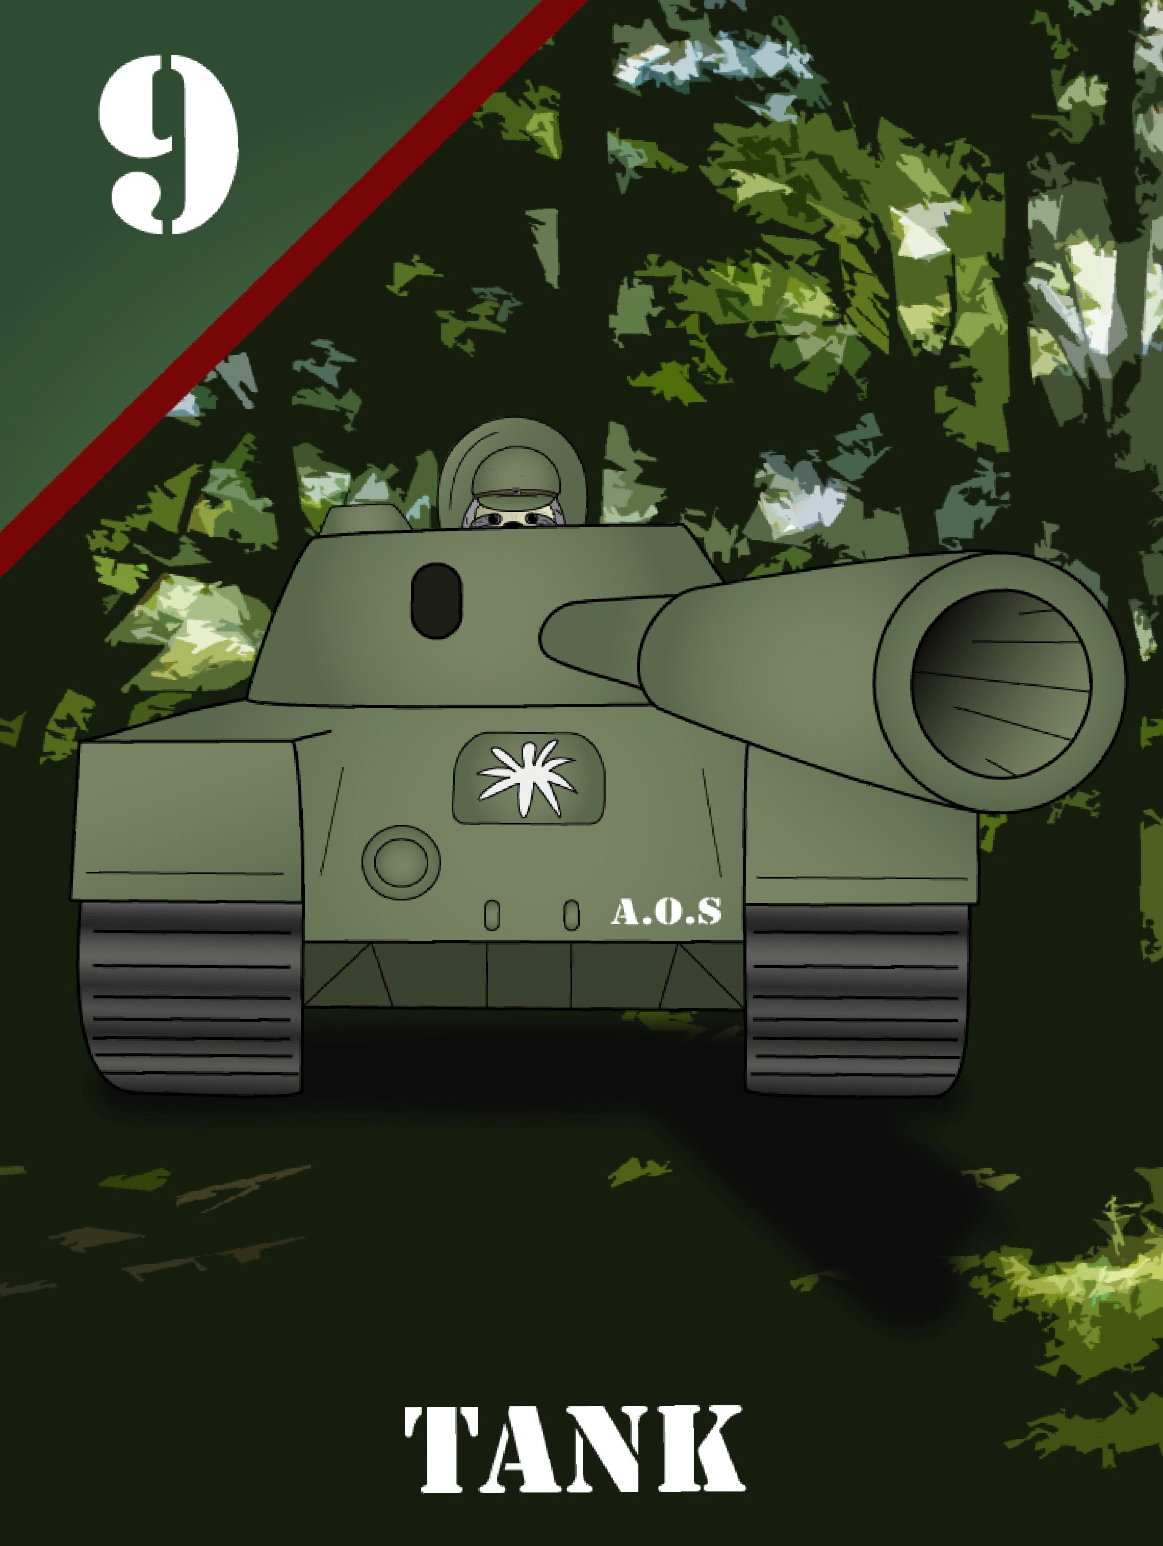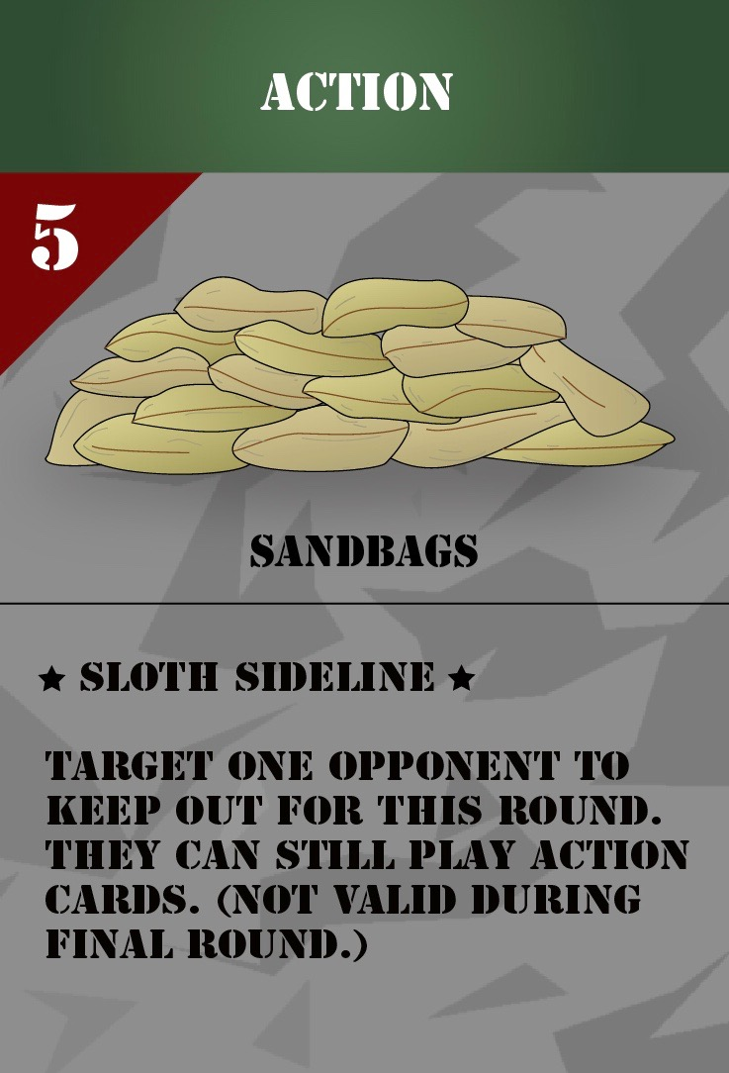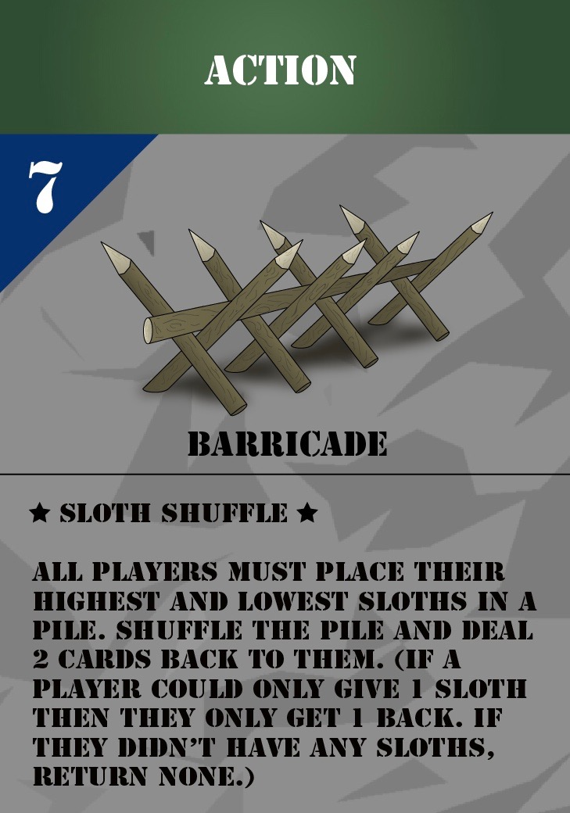

There are two actions on each action card and that is because Army of Sloths provides you 2 ways to play (Leaf Defenders and Leaf Conquerors). The top action is used for Leaf Defenders, and the bottom action is used for Leaf Conquerors. Whether you’re looking for a longer game to enjoy with family and friends, or a short play session to kill some time, Army of Sloths can be the game for you (playtimes may vary).

Gameplay:

The first way to play, Leaf Defenders, focuses on building up your defenses, while simultaneously working to weaken your opponents’ defenses. It is your goal to keep your leaves safe, and capture your opponents’ leaves. If you lose all of your leaves, then you’re out of the game.

Build up your walls, and knock down others’. Find the right balance between strengthening your walls and attacking your opponents. The last player with leaves in front of them is the winner.

This game is designed for 2-4 players, but is best played with 3-4. A typical game can take anywhere between 20-45 minutes to complete, depending on the number of players.

The second way to play, Leaf Conquerors, is easier to learn and quicker to play. In Leaf Conquerors players compete round by round in order to obtain the most leaves. Players are dealt a combination of sloth and action cards, with the leaf cards set off to the side in a pile of their own.

At the beginning of each round all players draw a card and then decide if they wish to play any action cards. A card from the top of the leaf pile is then flipped over for everyone to see. Players must now decide whether or not they would like to battle for the leaf by placing a sloth facedown in front of them. All sloths are flipped simultaneously and the player most powerful sloth wins the card.

The leaf cards have varying point values. Some are worth 1 point, some are worth 2, and one is worth 5. The 5-point leaf, also known as the Golden Leaf, will always be the final leaf to be drawn. The player with the most points at the end of the final round is the winner!

This game is also designed for 2-4, but has an average playtime of 15-20 minutes.

For more detailed information about the rules and gameplay for both ways to play you can check out our Facebook page (Army of Sloths), or our Twitter (@DoubLLeGames)! A complete set of rules can be found in both places.

Kickstarter!

Army of Sloths is still in development and will be launching on Kickstarter at the end of 2017!

Thank you all for taking the time to read about Army of Sloths. We greatly appreciate it, as well as any support you can offer. Any questions you may have, please feel free to ask via social media. We look forward to building a community with all of you as we continue our work!

