Award-winning puzzle game MOLECATS will be available on Xbox One on May 17.

Meet the Molecats – quirky mole/cat hybrids forever digging underground for tasty mushrooms and shiny relics!

Molecats (www.molecats.com) is a true labor of love for multinational developer Vidroid (www.vidroid.com) – which has won several awards and produced sought-after talent, such as: sound designer Samuel Justice, who is credited on a number of AAA titles such as B4, Soma, and Paragon; and composer Vasiliy Kashnikov, who wrote the scores for Knock-knock, The Void, and Cargo! The Quest for Gravity.

Watch the trailer below to get a feel for the game’s charming, unexpected underground world:

https://youtu.be/yx62zpo2eVI

In the game, your job is to help the aforementioned Molecats secure ever-important foodstuffs (‘shrooms) and loot (relics). Guide them through dangerous underground tunnels by twisting and turning tiles – indirectly controlling where and how your crew tackles each challenge. Spooky monsters and devious traps are lurking around every corner: Take your time and plan each move carefully to keep those Molecats smiling. Of course, finding the exit with both goodies and limbs intact is great – but stay on the lookout for achievements, secondary goals, unlockables, secret levels, and more. You never know what you’ll dig up...

The funky puzzle game from indie developer Vidroid has won several awards – thanks its intricate visual design, innovative gameplay, and lovable characters.

Awards
- Indie Prize Showcase USA 2018 - Best Game Design Award
- Indie Prize Showcase USA 2018 - Most Innovative Game Award
- Digital Dragons 2018 - Rookie of the Year Award
- GTP Indie Cup 2018 - Best Art Award
- Indie Prize Showcase Europe 2018 - Best Children’s Game Nomination

Key Features
- Enjoy simple yet challenging gameplay as you solve clever puzzles by rotating tiles to connect paths and apply special powers.
- Avoid dozens of obstacles, monsters, and traps that try to slow you down.
- Keep trying without dying: Every mistake leads to even more puzzles.
- Discover and unlock tons of achievements such as secondary goals, mysterious unlockables, secret levels with unique game mechanics, and more!
- Explore an adorable world and meet a slew of unforgettable characters.

Pricing & Availability

Molecats will be available on Xbox for only 12.99$.

Twitter
Award-winning puzzle game MOLECATS will be available on Xbox One (downloadable?) on May 17!
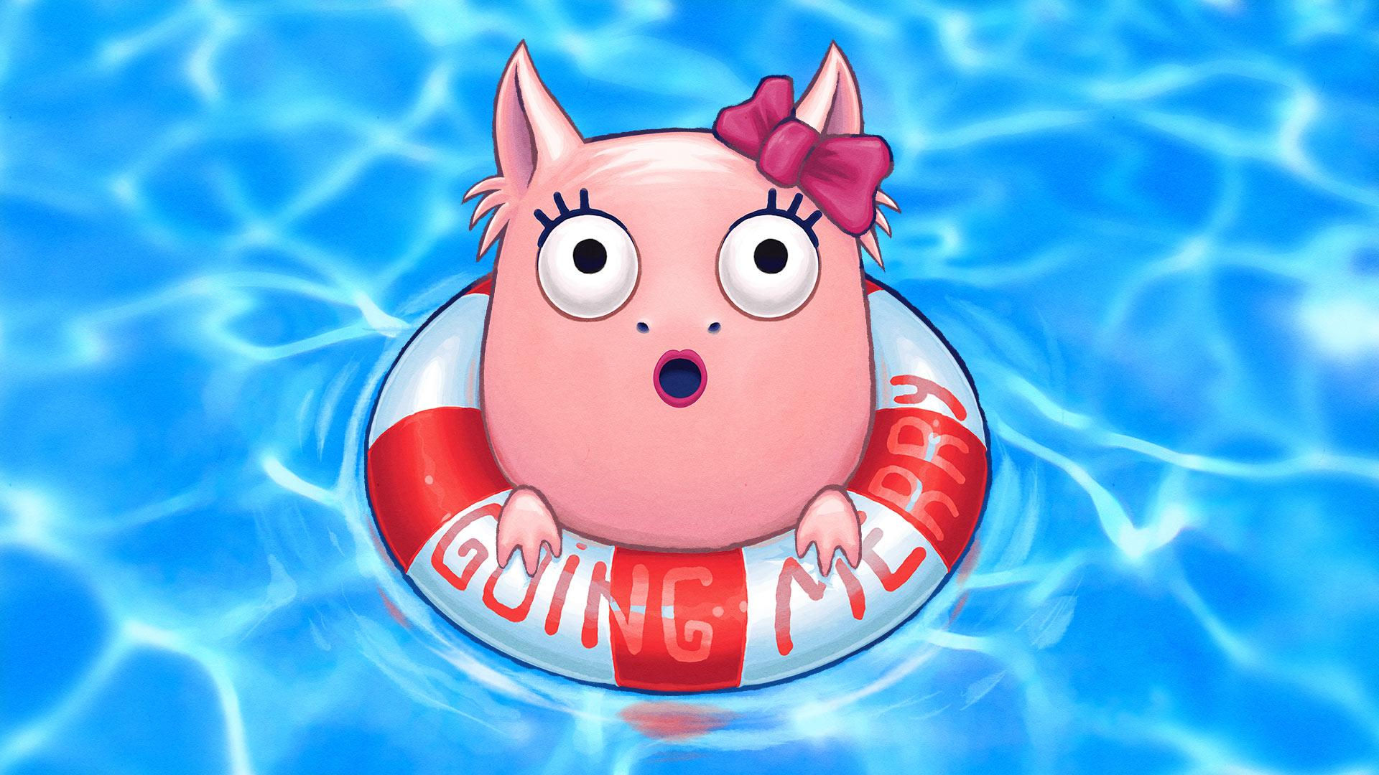
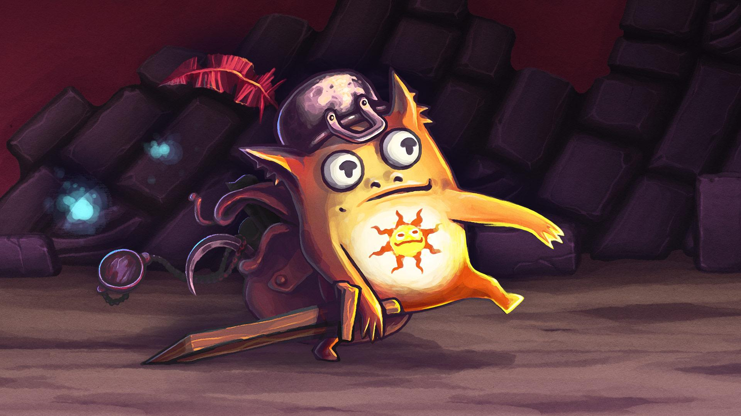
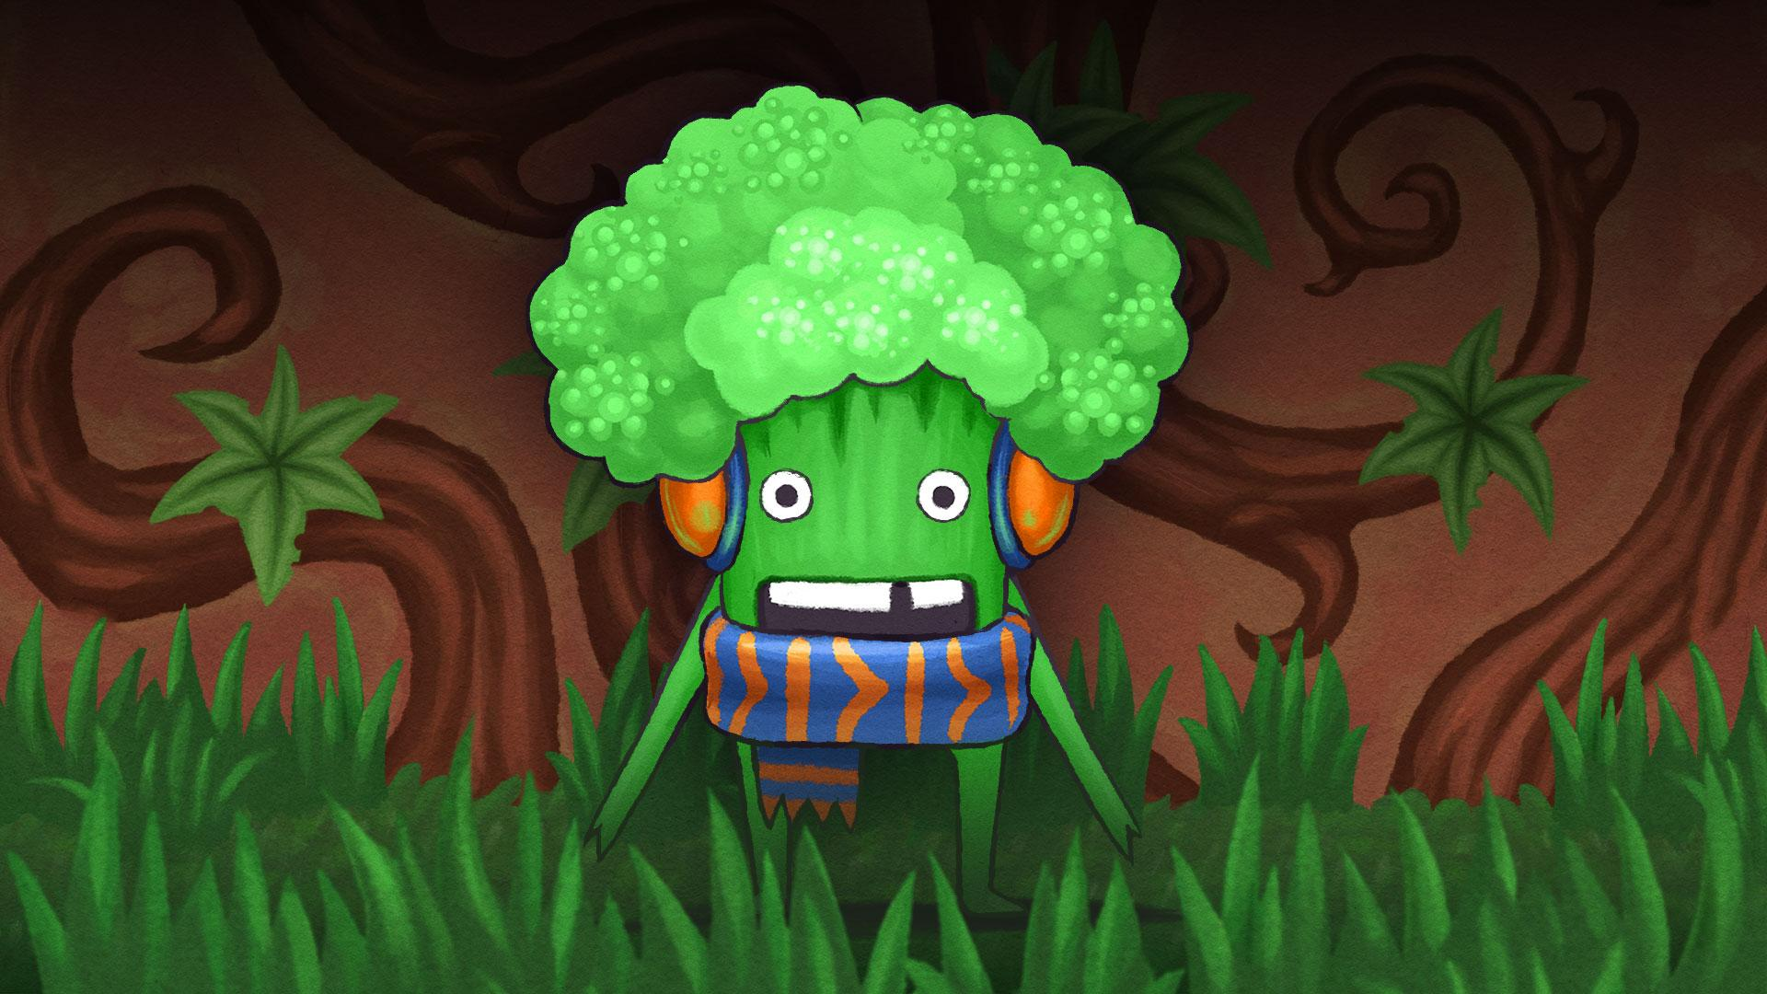
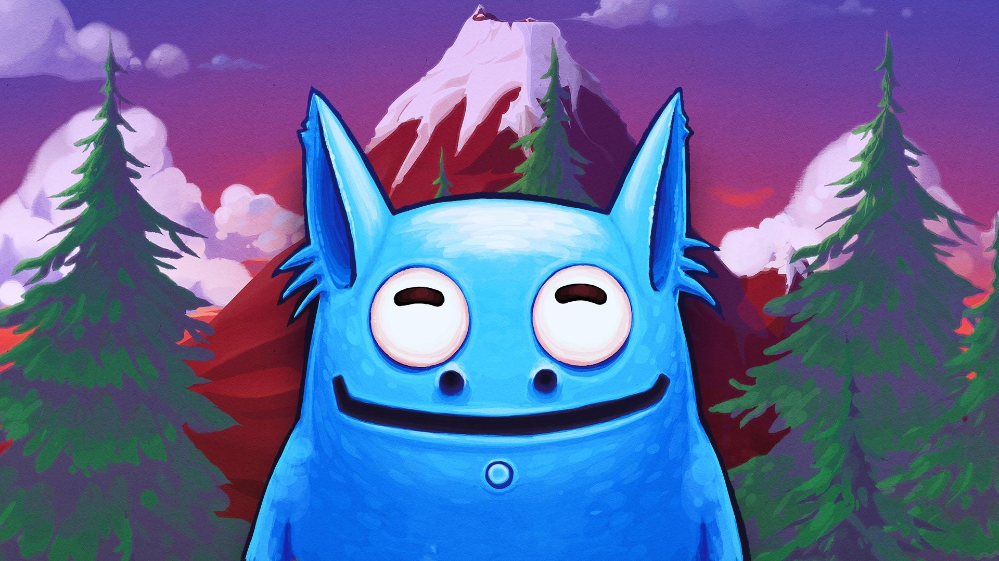

Wired Post

Molecats started off as a tiny project that grew over the years of “garage” development, with almost no budget or planning. And so, Molecats are finally here.
What was the point?

We (Vidroid) are from the generation of post-Soviet computer geeks, who have studied English and computer science only to be able to assemble & setup PCs and understand what this “new video game” is about. The world of video games back then was a whole uncharted territory, which we craved to explore. The language barrier. No printed manuals, guides or internet to search for walkthroughts. We shared our experiences with friends and learned a few tips from each other.

When we came across a puzzle-filled game, it was really difficult without any help from the outside. We remember and treasure this experience. And we realize that it doesn't appeal to everyone at present days, just because games become more mainstream. But we feel that there is a gamer, who still likes to be puzzled, a patient gamer, a gamer who can pause the game to think about his strategy, a gamer, who are not afraid of hair-yanking challenges. Thus, we have tried to convey this experience in Molecats, but with a modern look and simple controls.

The development of Molecats began as a friendly competition with our colleagues: we decided to make several prototype games based on “tiles”. We have always liked the tile-placing board games from our childhood, especially those in which you place and rotate tiles, paving new paths for your characters, collecting treasures and finding a way out of the dungeon.

So, we built a dungeon out of tiles.

The second important idea, which was present from the very beginning, was that our characters had to be independent creatures that we could not control directly. They must be living their own lives in a dungeon, minding their own business. At first they were much smarter, but it became obvious that they would be too difficult to control with simple means.This is how creatures became “Molecats” - a mushroom loving cat/mole hybrid simpletons, which endlessly march in caves. Later, their dummy behaviour was explained by acquired forgetfulness, but how and why they were affected and whether they will be healed from - this is a Story the game itself will tell.

