**For more Informations**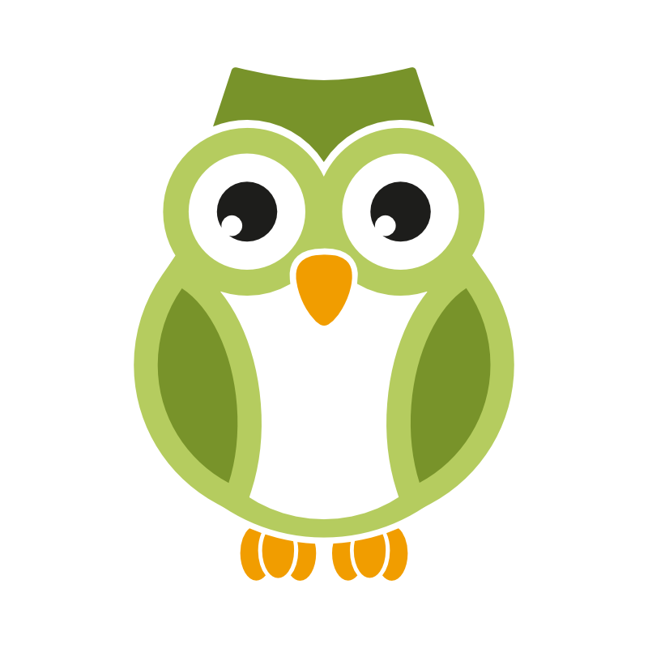

Carla Ventura

+351 960226334

[geral@play4edu.com](mailto:geral@play4edu.com)

# Princess Agnes and friends

Educational App for children in preschool and first primary year

**Setúbal, Portugal, 9th December of 2015**

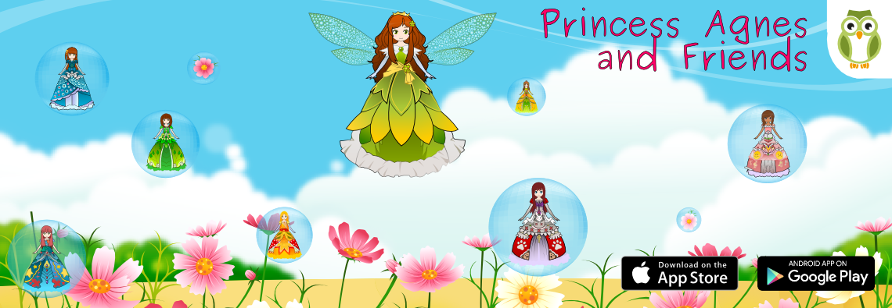

Join Princess Agnes and her friends, as they play and practice basic skills on a fantasy scenario. The main game is a dressup game with Princess Agnes.

* Available in Spanish, English, German or Portuguese
* 8 different educational and fun games teach children about music, letters, shapes, math, animals, sequences and matching.
* More than 10 puzzles in the puzzle game
* Play 8 different instruments in the music game
* Train additions and subtractions from 1 to 10 in the math game
* Learn the alphabet by drawing in the letters game

#### How the app works

This app is a full immersion in the language. Children follow Agnes’s instructions in the main menu and listen to her reinforcements and rewards. The user chooses a princess and follow her instructions on each game. Each game is easy to play and focuses on a basic skill.

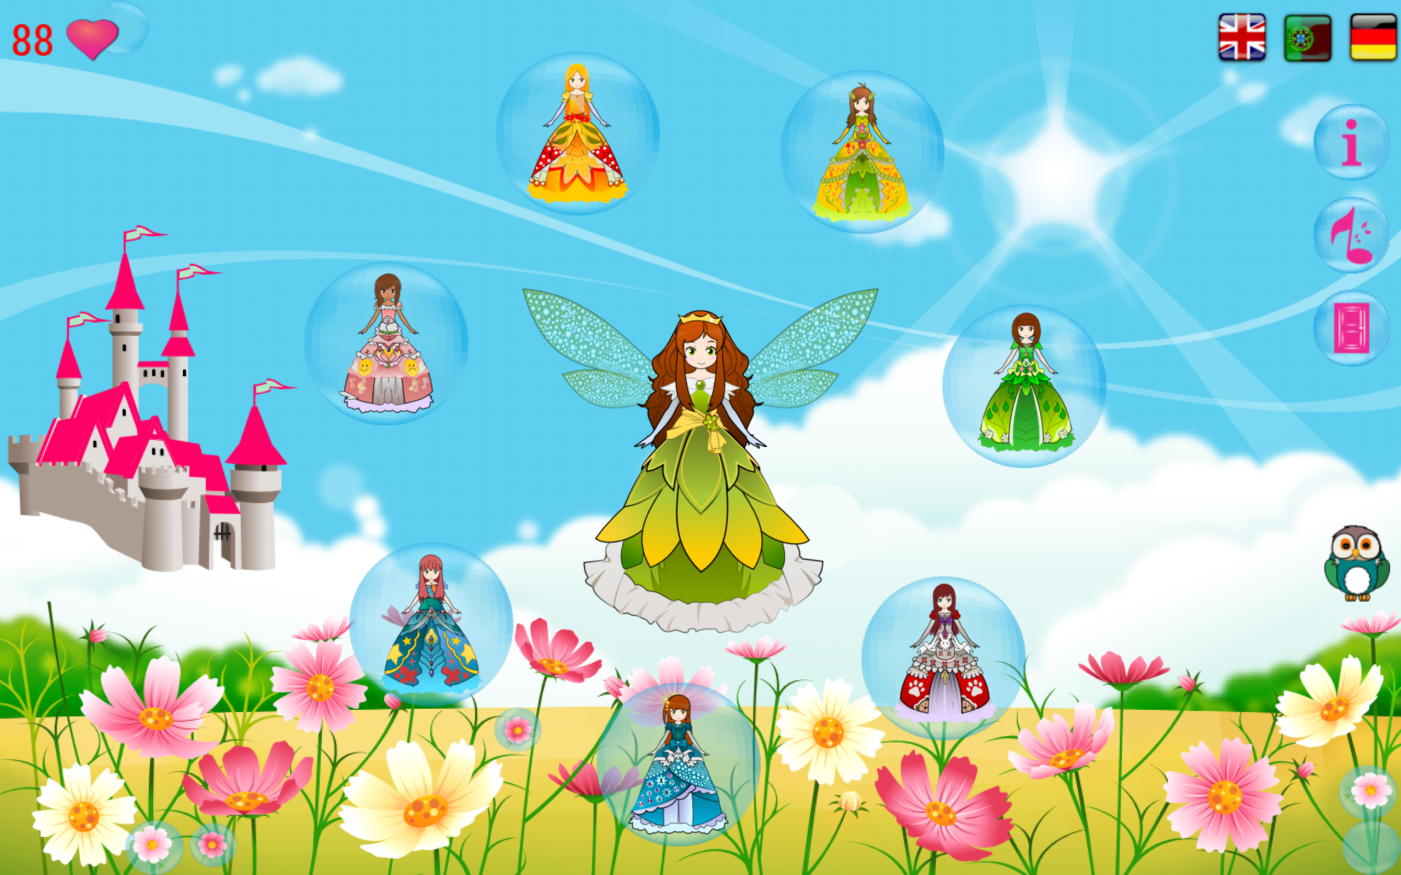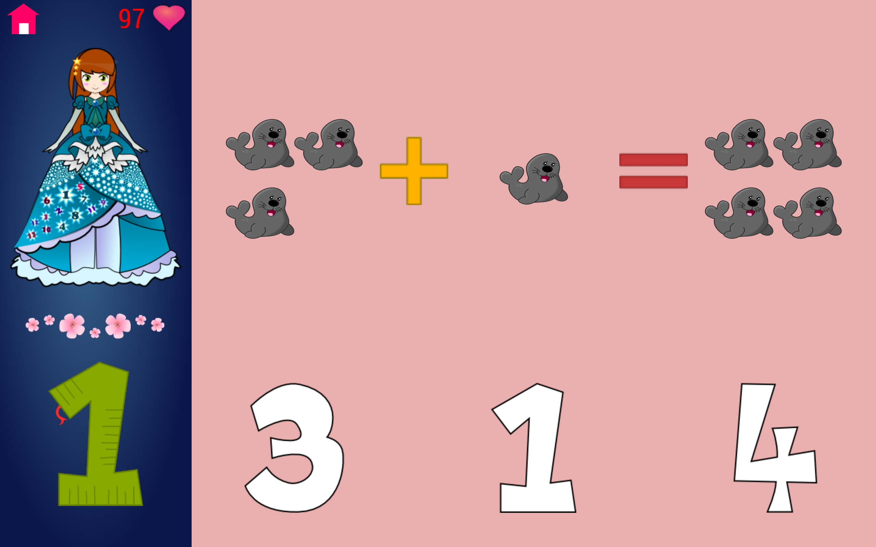

This is princess Agnes and the favourite of the children, here the child can dress up the princess with the hearts she gained with the other princesses in educational games.

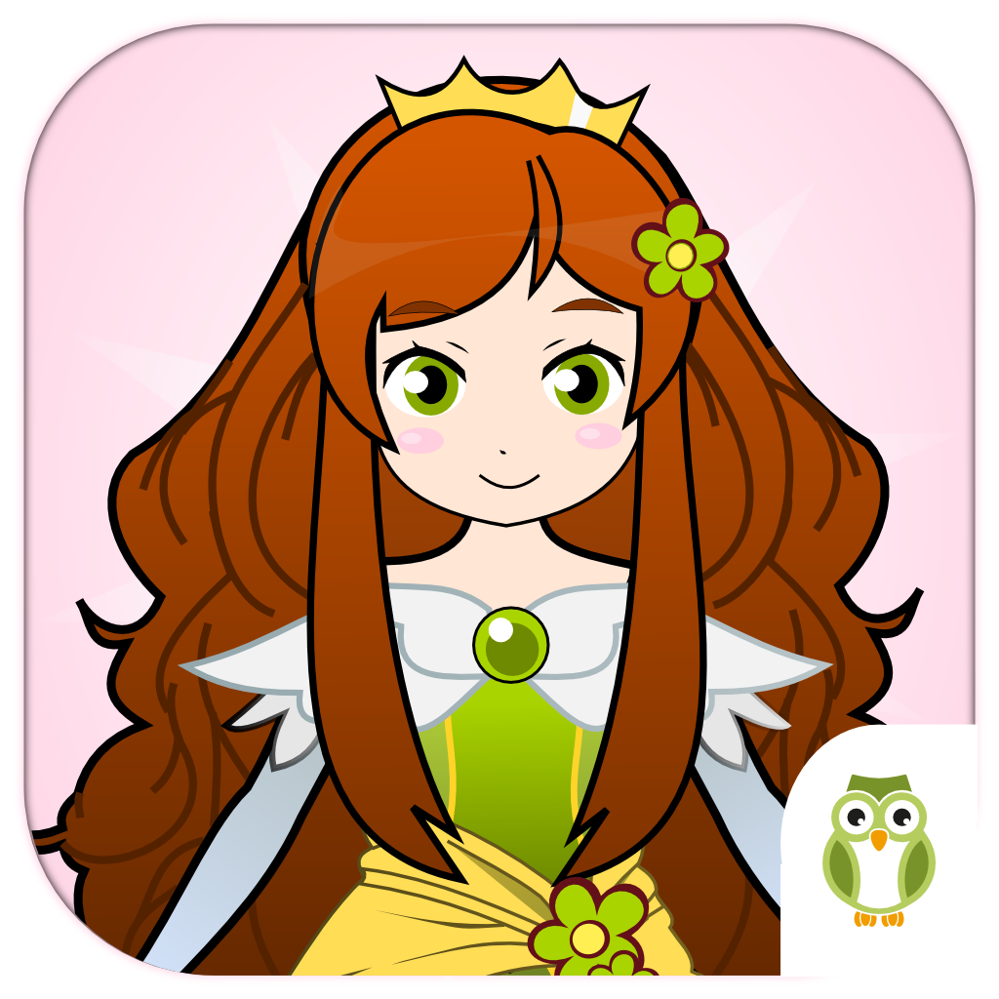

**More Informations in:**

Site: [play4edu.com](http://play4edu.com/)

Google Play: https://play.google.com/store/apps/details?id=com.itsimples.princesses.android

App Store: https://itunes.apple.com/us/app/princess-agnes-and-friends/id1022294784?mt=8

Facebook: <https://www.facebook.com/play4edu>

Twitter: <https://twitter.com/Play4Edu>