ReBounce Press Kit

Name of Game: ReBounce
App Icon:
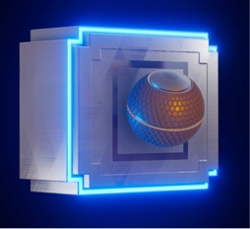
Price: Free

Elevator Pitch Description: ReBounce is a fast-paced hyper-casual arcade game. Throw the ball against the wall, avoid the daunting landmines and empty space to gain points, and achieve a high score!
Platform: iOS
Projected Release Date: September 31,2018
Studio: Titan Flight Studios
Website: www.playrebouncegame.com
Social Media: Twitter, Instagram, Facebook
Contact Email: jon@titanflightstudios.com
Full Description: ReBounce! Tap the screen to throw the ball against the wall, and catch it after it glows orange to score points—don’t miss it! Bounce the ball off surrounding walls to gain point multipliers. Be careful, wall tiles will disappear, giving you less real estate to work with.

ReBounce reinvents the classic schoolyard game of Wall Ball by adding a few interesting mechanics that you will surely never experience beyond the digital realm:

* POWER-UPS - Gain brief power ups by throwing the ball against tiles that briefly light up one of three colors. Green tiles double your score multiplier for 10 seconds. Yellow tiles grant invincibility for 10 seconds (missing ball doesn’t count). Blue tiles restore half of missing wall tiles.
* OBSTACLES - Watch out for the explosive mines! The further you get in the game, the more mines you deal with. Use invincibility to destroy mines!
* DIFFICULTY MODES - by default, the game is in casual mode. It allows for three chances before the game is over. Hard mode only allows one chance. Be mindful of your tapping in this mode! Mis-tapping the ball on its way back will mean game over.
*COMING SOON* Multiple different designed balls that users will be able to earn and collect throughout playing the game.

- DEVELOPER NOTES -

|Supported Devices|
- iPhone - any iPhone model older than the 6/6s/SE is not supported.
- iPad - any iPad older than the Air 2 is not supported.

|Bugs|

We strongly believe that ReBounce is bug free. We would also, however, like to be proven wrong! Please report ANY major game breaking bugs to support@titanflightstudios.com so that we can fix them ASAP.

Thanks for playing! Feel free to write an awesome review if you like the game!

- Titan Flight Dev Team

What Others Are Saying:
“I enjoy playing because you can play it like a rapid fire game or slowly to be more precise, so however you play it’s at your own pace” -Grayson S., Beta Tester

Images:
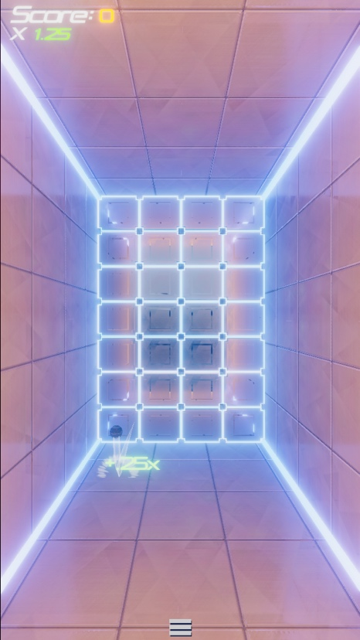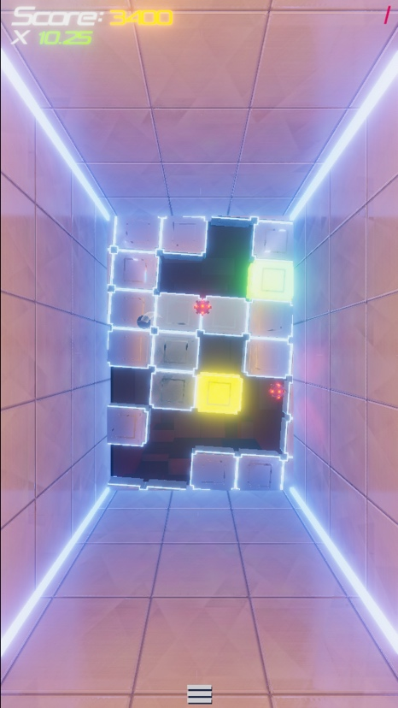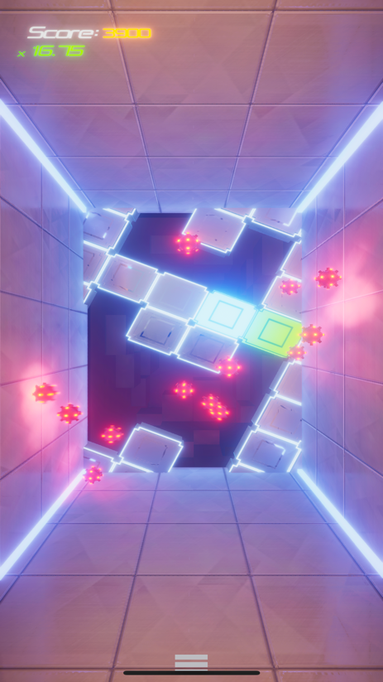
Video: Sample Gameplay

