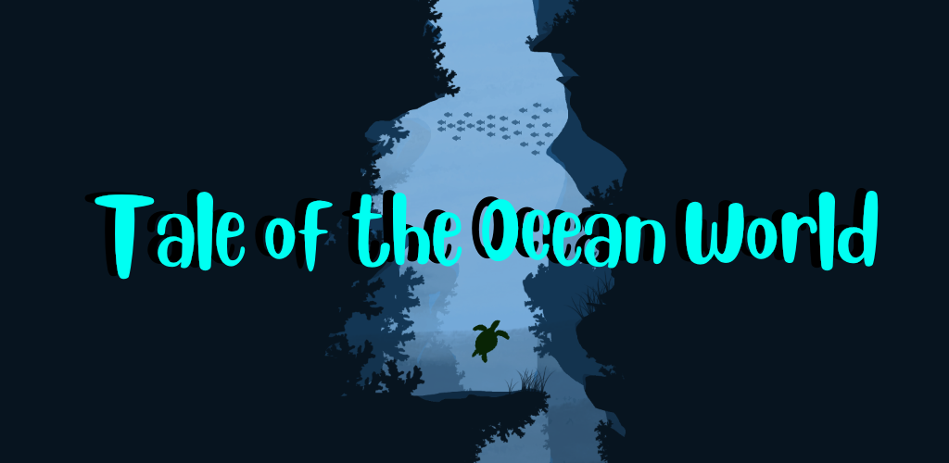
Quick Facts:
Name: Tale of the Ocean World
Location: Denmark
Release Date: End of development phase (Date to be decided)
Platform: Android
Price: Free (Includes in app purchases)
Game Introduction:
Human negligence has gone too far and began to hurt ocean wildlife. Understand the consequences of marine pollution, and the way it affects creatures and life in the oceans. Playing as the turtle named Biscuit you go forth to save your parents from fishermen who have been polluting your home and capturing animals.
Features:
● Swim through beautiful environments and dodge different types of pollution
● Collect aqua points by freeing fish and collecting oil spill
● Buy extraordinary items to help you during your adventure
● Experience the achievement system by completing tasks and earn rewards
● Acquire skins to customize how Biscuit looks like
● Play through each environment to unlock newer ones
● Catch up to the fishermen to free your friends and parents and experience a Boss Battle
● Spread awareness for ocean pollution

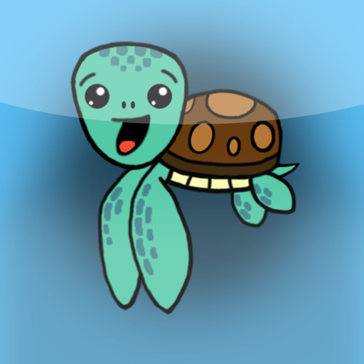
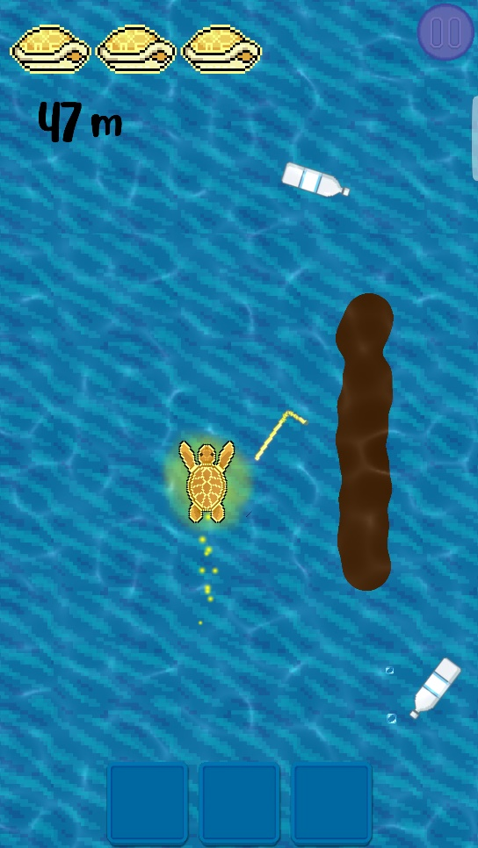
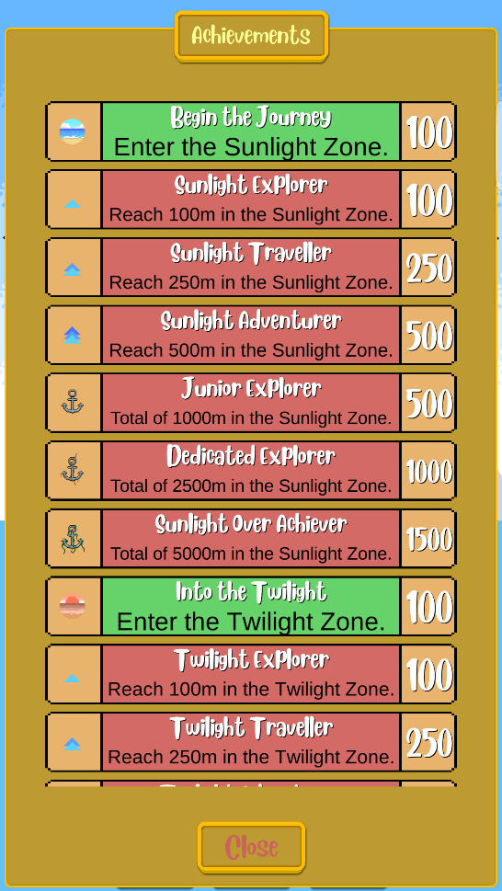
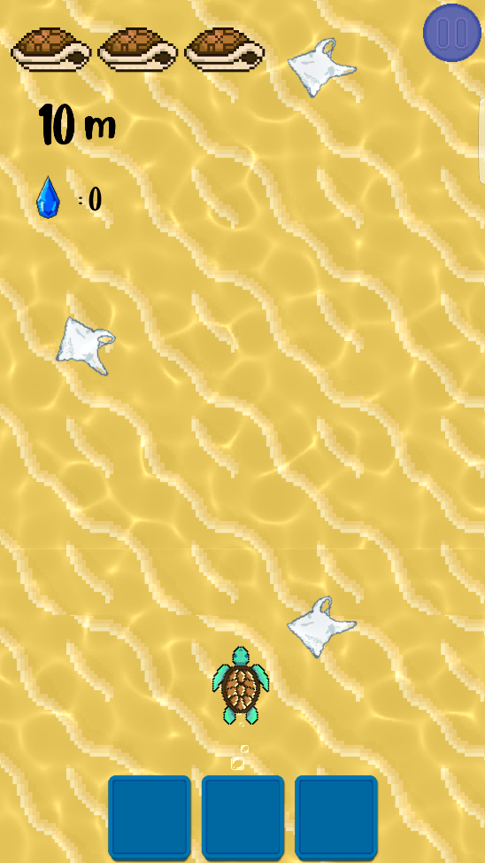
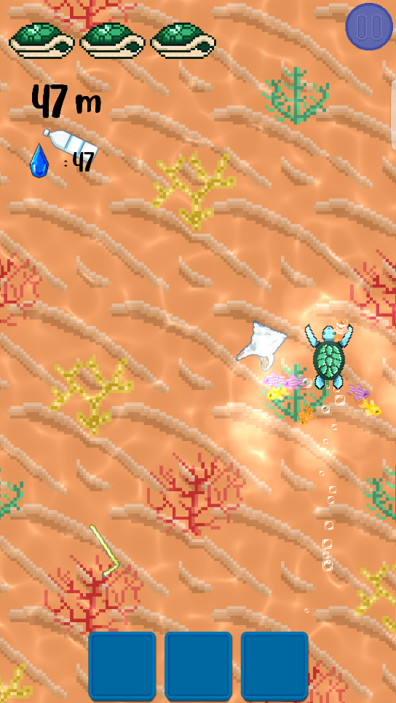

About us:
We are 2 ordinary guys, both working and studying in Denmark with a dream that we want to make a reality. We both come from Bulgaria and a year ago we decided to collaborate on a small project to spread awareness about pollution. Having previous knowledge in computer software and game developing we began working on our very first game. By developing this game, our goal is to raise awareness in the younger generation about these issues, so when they grow up, they can make a change and leave a positive mark on this planet.
Studio E-mail: ufuturestudio@gmail.com
Personal E-mail: tsvetelin.dim@gmail.com

Permission/Disclaimer:
This part of the document is to give permission to use all of this content for commercial use. Any files attached with this document fall under the same permission as this document. Use at your own risk.

