Short Description
Unique QTE combat strategy RPG. Collect runes, choose tactic, explore uncharted area, and defeat powerful enemy.
◆ Exciting real-time combat.
◆ Different combat style for each monsters. Develop best strategies!
◆ Explore uncharted, encounter various event.
◆ Finish adventure mission and get reward.
◆ Find fortune and honor in arena.
The character in <Rune Rebirth> is a "Spectator", travel around the world after the war of six gods, and discover stories, race, and legends. In this land, "Rune" has replaced blade and magic and becomes main weapon. Power of attack, heal, and bless can be released and used in combat via control the "Rune".

Full Description
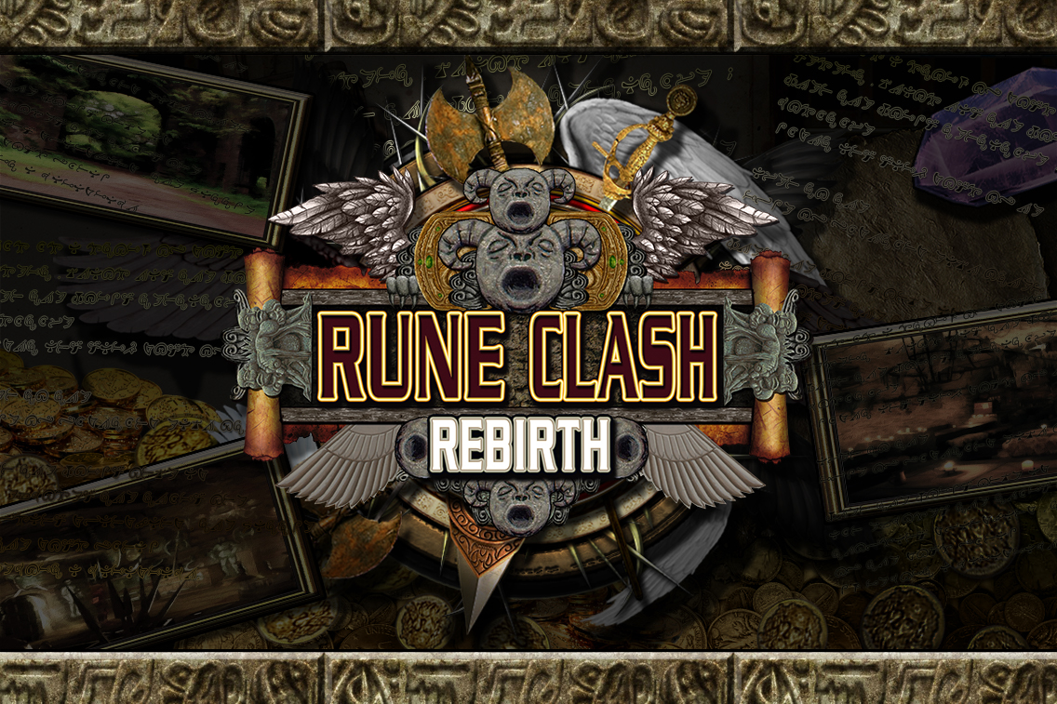
Game Title
The character in <Rune Rebirth> is a "Spectator", travel around the world after the war of six gods, and discover stories, race, and legends. In this land, "Rune" has replaced blade and magic and becomes main weapon. Power of attack, heal, and bless can be released and used in combat via control the "Rune". We like to present an old-school RPG style no matter in art, UI, or game setting.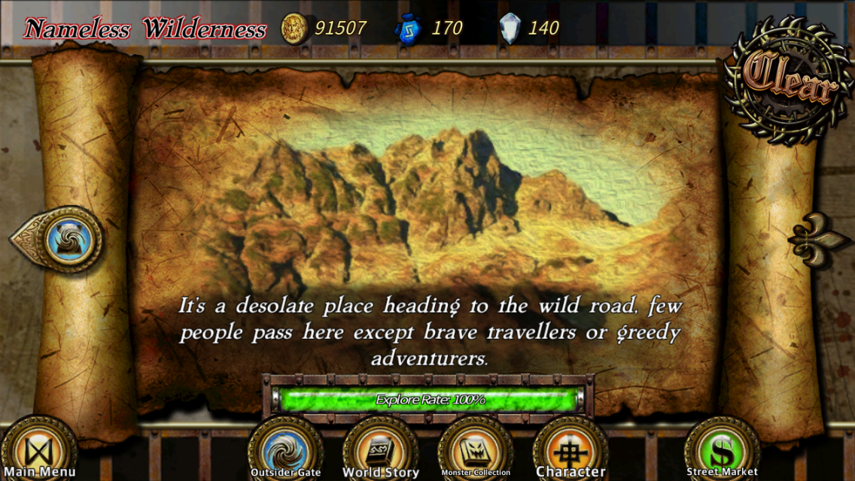
Adventure begin!
Player explores the stages one by one. After enter the stage, adventure path is drawn automatically during explore. Old scroll, compass, map pointer, and unknown adventure, make players fell like they are watching an Indiana Jones film.
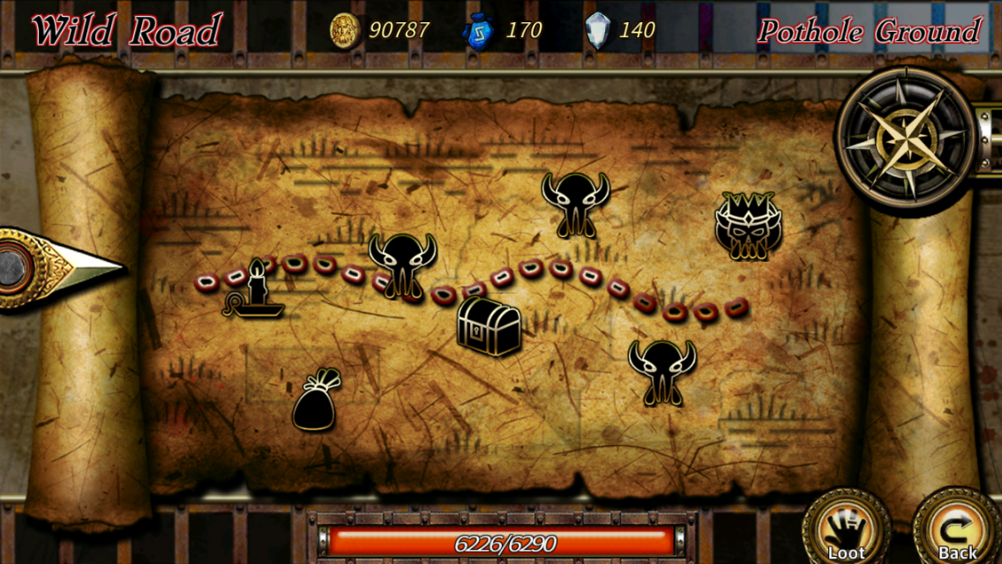
Exploring the stage
Various events happen during the journey. Different choices will result in different result and reward.
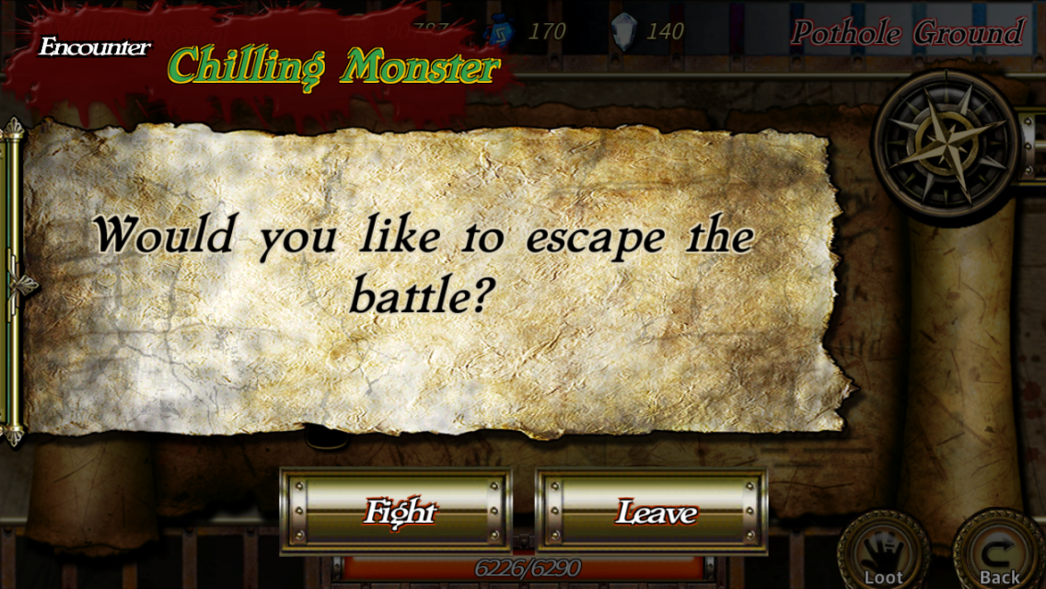
What is your decision?
We cannot call it "Adventure" if there is no danger. When encounters enemy, player can experience main features of game: Sigil combat system. Six runes can be equipped and used in combat. Several "Sigils" will appear in center of screen after press the rune button. To "active" the rune successfully, player must use "Sigil button" on both sides of the screen to input all symbols in order. Number of "Sigil" represents the "Cost" of that rune. Powerful rune has higher cost.
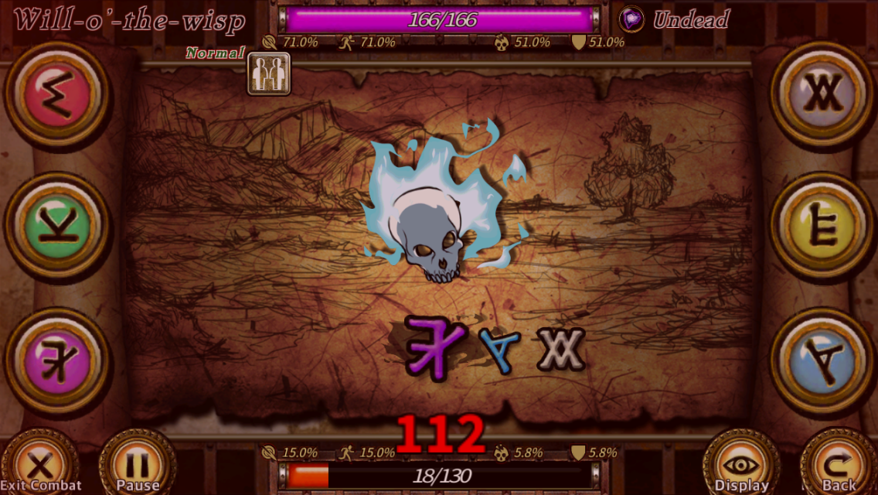
Input "Sigil" according central hint
This QTE-like system looks simple. However, combat is real-time. Enemy keeps moving during player inputing the "Sigils". Some monsters may even disrupt the players with special skills like flare, sprinkle sand, and so on. Block and critical hit opportunity will, moreover, randomly happen in combat. Those materials compose a frantic and intense combat!
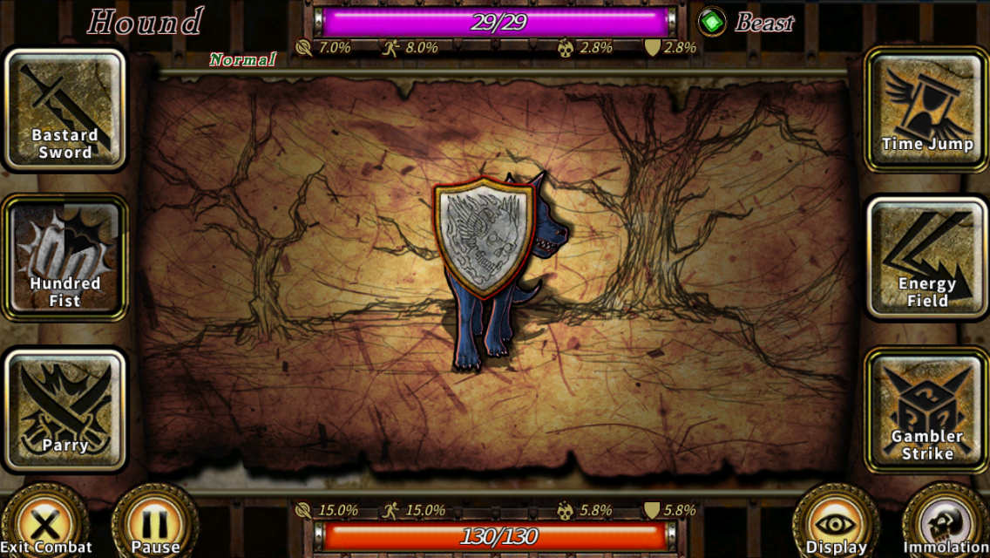
Shield button appears, press it immediately!
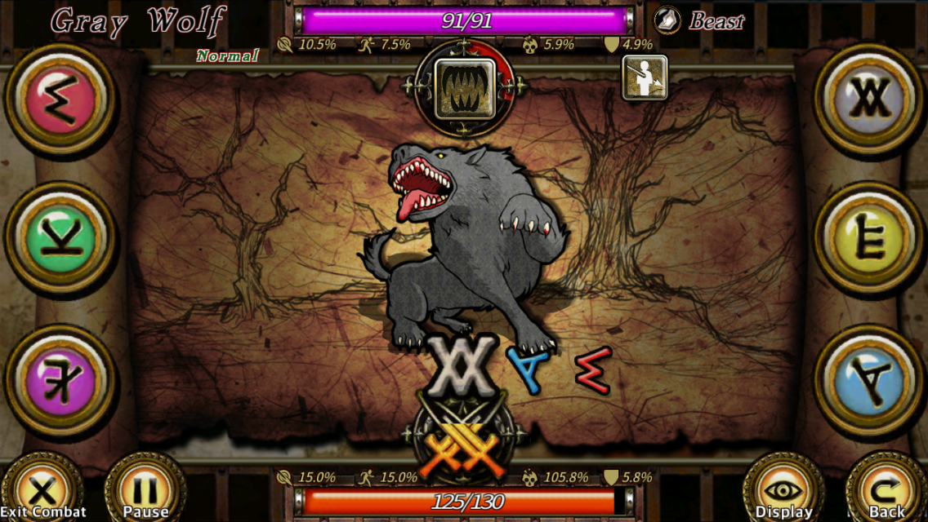
Input all sigils before the sword progress bar runs out to cast a critical hit.
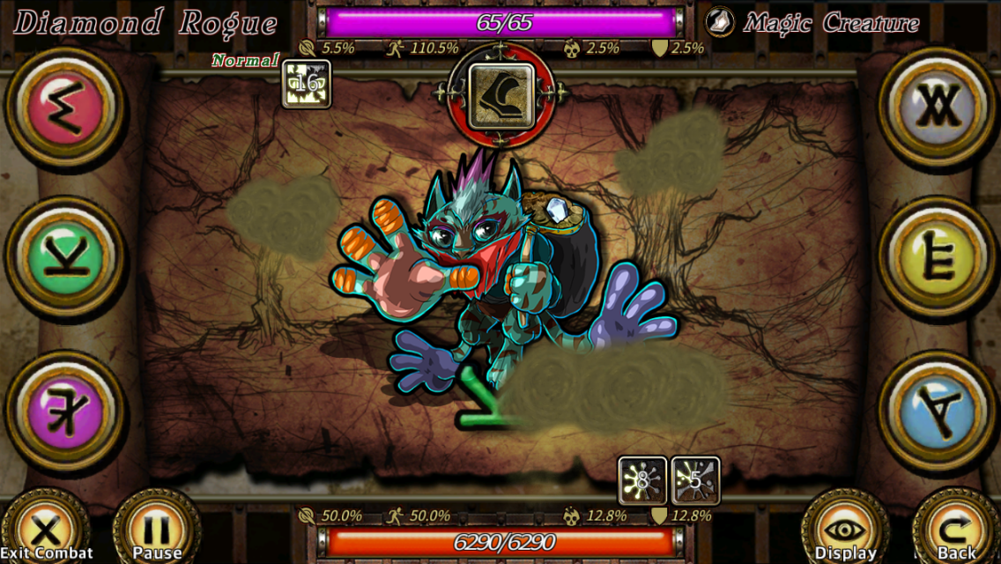
Annoying【Sprinkle Sand】skill
There is no race or class limitation in game. The usage of runes is totally flexible. Player must choose appropriate runes when faces different stages and enemies. Runes can be obtained via NPC shop, enemy drop, and adventure events. Besides, runes can also be enhanced or imbued with element crystal. There are hundreds rune in game, it will be a challenge to think most efficient tactics and choose unique combat style.
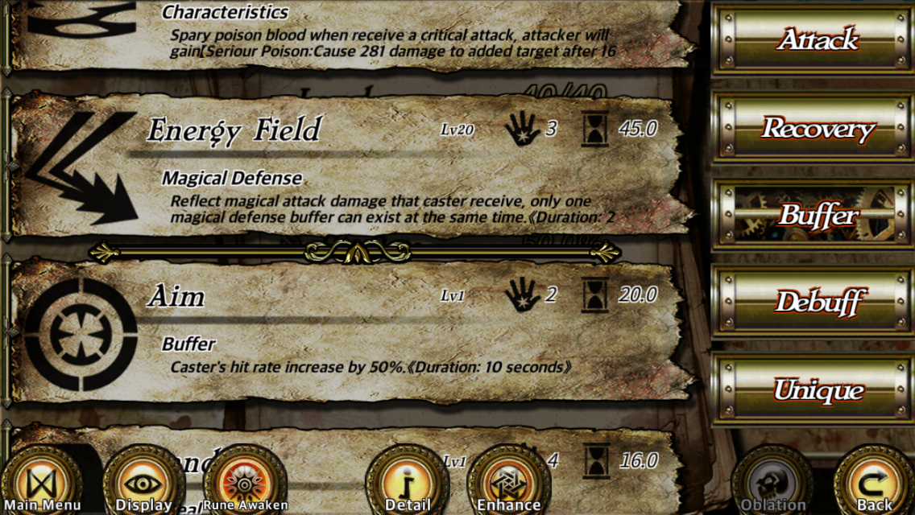
Choose runes carefully
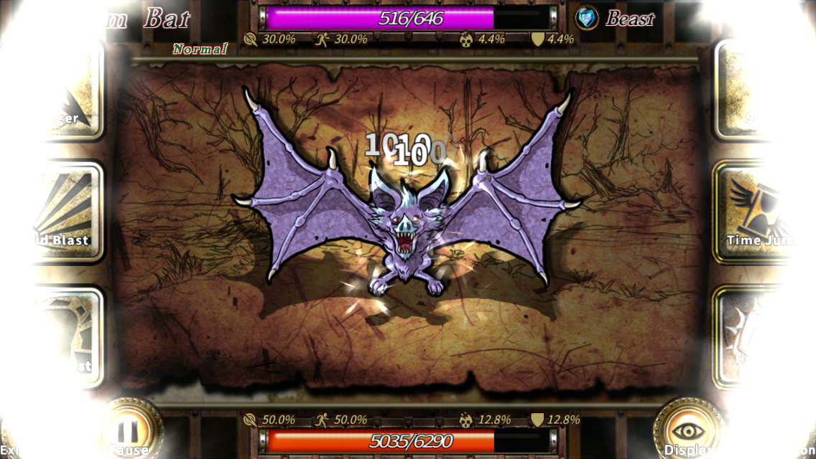
Unique rune【Hundred fist】
Mission, arena, and bar system are good place to earn more gold or get some information in addition to main stages. Map merchant provides various bonus stages. Danger or treasures in those uncharted? Depends on your luck!
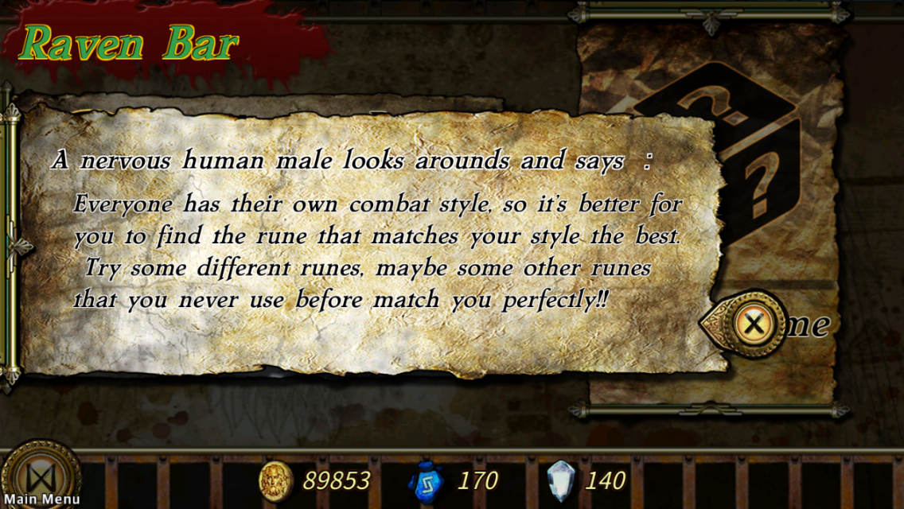
Hear some news in bar
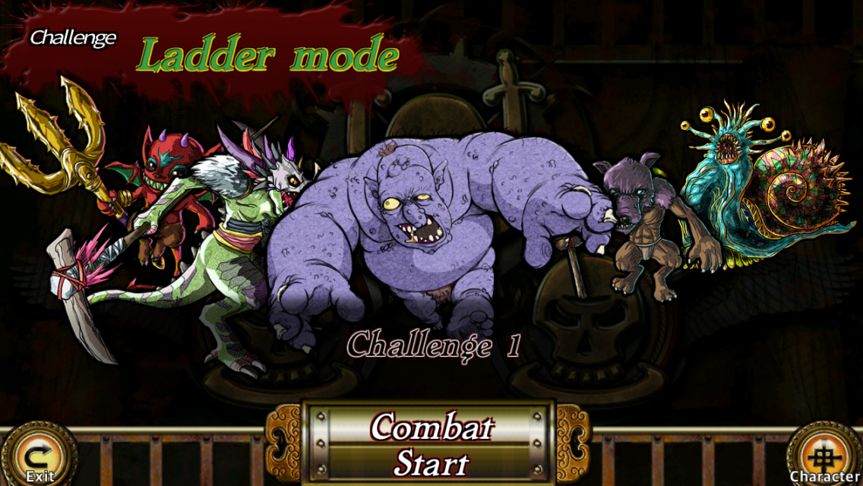
Ladder mode of arena

