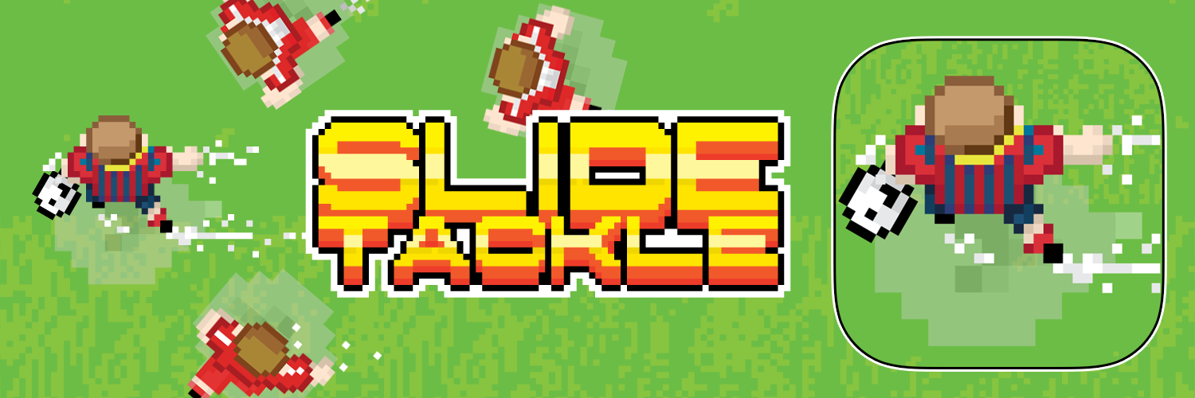

'Slide Tackle'
Available on the Apple App Store, Google Play Store and Amazon Underground

A fast paced, one finger endless arcade runner for football/soccer enthusiasts!

Slide Tackle is a fast paced, always different, top down endless football/soccer inspired arcade runner. Each time you play the field types, defenders speed/start position, amount of defenders, obstacles amount/location and possible power-ups are always randomly generated. Currently there are over 50 players to choose from. These include international squads, English and Spanish club teams and special powered players. Slide Tackle does not have any forced ads, time limits, health regeneration or anything else like that, there are no limits to you playing!
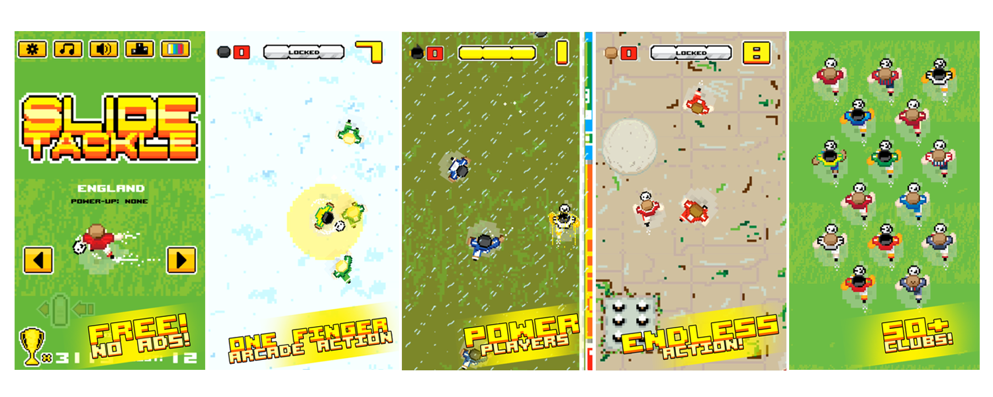
Slide Tackle is available now free for tablets and phones on the Apple App Store, Google Play Store and Amazon Underground. With the Amazon Underground version coming fully unlocked at installation.

Slide Tackle Website:
http://www.myinstallkit.com/slide/

Press Kit:
http://www.myinstallkit.com/slide/press/

###

Contact Me:
[EMAIL] attudesign@yahoo.ca
[TWITTER] @lsdelamater

