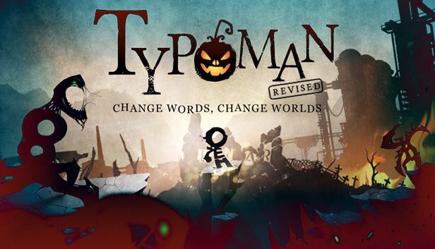

***Typoman: Revised* delivers Halloween treats with biggest ever Steam update**

* *New game modes add over 150 new challenges and hours more entertainment*
* *Players can save 34% on Typoman: Revised and the game and soundtrack bundle*

Bonn, Germany, 28 October 2016 – Independent game developer [Brainseed Factory](http://www.brainseed-factory.com/) today announced the release of the biggest ever update to its award-winning puzzle platformer *Typoman: Revised.* Coinciding with Steam’s Halloween sale, Brainseed Factory is also selling the game at 34% off for a limited time only.

Winner of numerous accolades, including the “Best Production” award at the German Video Game Awards and Gaming Trend’s "Best Art Style" E3 Awards, *Typoman: Revised* is a story-driven platformer in which players craft words to solve puzzles and overcome traps.

Two new game modes form the core of the new update. The first mode, *Antonymizer* adds 168 new challenges as players seek to combine words with antonyms to solve puzzles. The second mode, *Word Hunter* pits players against the clock in a time-based challenge. Combining both speed and brain-power, players must form as many words as possible in 60-seconds to top their own high score.

"This is a gift to our community; to everyone who enjoyed the game and was hoping for more content." said Bilal Chbib, CEO of Brainseed Factory. "This update adds two new challenges with endless play mode and a ton of new word effects and animations to keep players entertained for many more hours!"

*Typoman: Revised* is available at the discounted price of £6.59 / $9.95 / €9.95 for a limited time only from <http://store.steampowered.com/app/336240/>

Website: <http://www.typoman.net/>

Facebook: <https://www.facebook.com/typoman.net>

Twitter: <https://twitter.com/brainseed_fcty>

**-------Ends-------**

**Notes to Editors**

**Media kit** : <https://drive.google.com/drive/folders/0B_T8LEWh_3ozcVZxcWMxVnRPU0E?usp=sharing>

**Typoman: Revised trailer** : <https://www.youtube.com/watch?v=wjc-Sumxo_E>

**Downloadable version of the trailer**: : <http://bit.ly/2aM22Bi>

**About Brainseed Factory**

Brainseed Factory is an independent game studio based in Germany's former capital city, Bonn. It was founded by Bilal Chbib and is made up of 7 creative minds and gaming enthusiasts who love playing as well as creating unique, memorable games. Brainseed Factory's debut title *Typoman* has secured multiple awards and nominations at industry events worldwide.

**Media Contact**

For more information, including Steam keys, please contact:

Theo Tsangaris - [theo@biggamesmachine.com](mailto:theo@biggamesmachine.com)

Big Games Machine

[www.biggamesmachine.com](http://www.biggamesmachine.com)

+44 (0) 203 637 4244