“FOR IMMEDIATE RELEASE”

Onion Soup Interactive reveals UEDI: Shadow of the Citadel

Anime-styled open world action-RPG coming to Steam

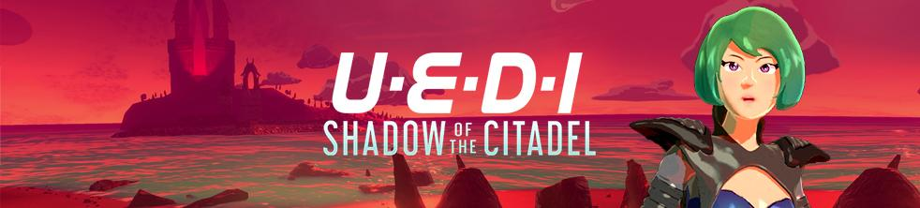
11 February 2020, London, UK - Today, Indie developer Onion Soup Interactive announced its latest game, UEDI: Shadow of the Citadel. The teaser trailer reveals the protagonist, a sprawling 15 miles² open world and hints at an intricate and mysterious story.
https://youtu.be/2CJZWoqwnFI
UEDI: Shadow of the Citadel is scheduled to land on Steam via Early Access in Q1 2021 and players can wishlist it now via the Steam store page:
https://store.steampowered.com/app/1236630/
Players take control of a hot-headed reporter named UEDI (pronounced ‘Weddy’), as she infiltrates a world placed on interplanetary lockdown by its ruling dictator Hazuki. Hunting for both an estranged friend and the inside-story on Hazuki's nefarious plans, which are locked deep within his impenetrable citadel, UEDI is thrown into a war. Her only hope for survival is to join the rebellion.
Will UEDI emerge enlightened or will she be forever trapped in the shadow of Hazuki’s citadel?
UEDI is an outsider in this strange world, bold and head-strong but also in over her head. As her abilities develop so does her personality and her relationships with the rebels.
Features:
- Experience love, loss, growth and sacrifice delivered through a motion-captured story.
- Engage in real-time combat with enemies that react tactically to your actions.
- Unlock new abilities, suits and weapons then overclock them to unleash their true power.
- Loot rations and craft supplies to top up your health, electrolytes and NanoSuit power.
- Spend more time in game and less time in menus by seamlessly switching between NanoSuit presets for the perfect combination of tech for any situation.
- On foot or on wheels, explore approximately 15 miles² (39 km²) of hand-crafted anime-styled open world.
- Plunder abandoned structures, fend off rogue mechanical hordes, fix and maintain vehicles and craft items in a bid for survival.
- Enter labyrinthine facilities, solve puzzles and battle bosses to emerge more powerful than before.
- Customise UEDI’s clothes, hair and makeup to become the most stylish badass around.
- Photograph UEDI in key locations and document the realities of Hazuki’s World for her truth-telling blog in a bid to reveal all.
“Onion Soup Interactive’s Discord community has been heavily involved in the development of UEDI: Shadow of the Citadel from the beginning. We’ve been dropping screenshots and details of the game in there for a while now and it’s really fun to chat and get feedback. This helps us stay on track with such a huge project.” says Amy Madin (Community Manager) “Sometimes I wonder if we’re crazy for taking it on but I couldn’t be happier with how atmospheric and engaging the game world has already become.”
“We're keeping the best parts of the action-RPG genre and we're redesigning the aspects that have become stale and feel dated. For example we're working on a really smart route finding system that takes into account your side mission requirements and the possible terrain you may encounter versus your ability level.” says Andy Madin (Developer) “I want players to feel connected to the world instead of being fixated on the minimap or being stuck in menus. We're totally avoiding the cookie cutter approach at all costs and we believe that will make for a memorable game worthy of players’ time.”
To help shape the future of UEDI: Shadow of the Citadel, players can visit the Steam page to add the game to their wishlists and be sure not to miss out on Early Access coming Q1 2021.
Press Assets
https://www.onionsoupinteractive.com/uedi-press-kit
About Onion Soup Interactive
Onion Soup Interactive is made up of Andy and Amy: the nomad developers with no fixed abode! Their love of adventure and pushing boundaries is what makes them tick and it’s why they want to create unique experiences; everyone is welcome to join them for the ride. Andy Madin is the sole developer, Amy Madin is the community manager and costume designer for UEDI. They draw from gaming’s rich history to create truly original experiences: how else could the existence of Nippon Marathon really be explained? Learn more at http://www.onionsoupinteractive.com
Press Contact
amymadin@onionsoupinteractive.com

