**HOUSE OF LIGHT launches today on Steam and GOG**

*Major expansion to narrative crafting RPG BOOK OF HOURS out today, along with discounts and definitive Anthology Edition bundle*

*London, UK* ( *26th September 2024 )* — Narrative crafting RPG [*BOOK OF HOURS*](https://store.steampowered.com/app/1028310/BOOK_OF_HOURS/) was one of 2023's unlikely indie hits. Despite being a weird, lonely indie game about managing an occult library, it sold more than 44,000 copies on Steam in its first month of sale and has now sold 100,000 copies with a 92% positive rating overall. The two-person team behind it is now back with [HOUSE OF LIGHT](https://store.steampowered.com/app/2834350/BOOK_OF_HOURS_HOUSE_OF_LIGHT/), a major update to the game which adds a novel’s worth of new content to the game.



**Download BOOK OF HOURS launch trailer:**

<https://www.dropbox.com/scl/fi/9lzw4z1anytpdina1wmjb/BOH_Launch_1080p_h264.mp4?rlkey=6uc9fcl881zy6bqt3atdlb278&dl=0>

**Key Details**

* **Release date:** Thursday 26th September @ 6PM BST / 10AM PDT
* **Platforms:** [Steam](https://store.steampowered.com/app/2834350/BOOK_OF_HOURS_HOUSE_OF_LIGHT/) + [GOG](https://www.gog.com/en/game/book_of_hours_house_of_light)
* **Price:** $14.99 / £12.99 / €13.99
* **HOUSE OF LIGHT has a 10% off launch discount** for the first week of sale, and is free to Perpetual Edition owners of *BOOK OF HOURS*
* **BOOK OF HOURS is 30% off in a Steam Daily Deal**, its lowest ever discount. The deal runs from 6PM BST / 10AM PDT on 26/09/2024 - 03/10/2024
* A new **Anthology Edition bundle offers 15% off all *BOOK OF HOURS*, HOUSE OF LIGHT and the *BOOK OF HOURS* original soundtrack**, giving the greatest value to new players

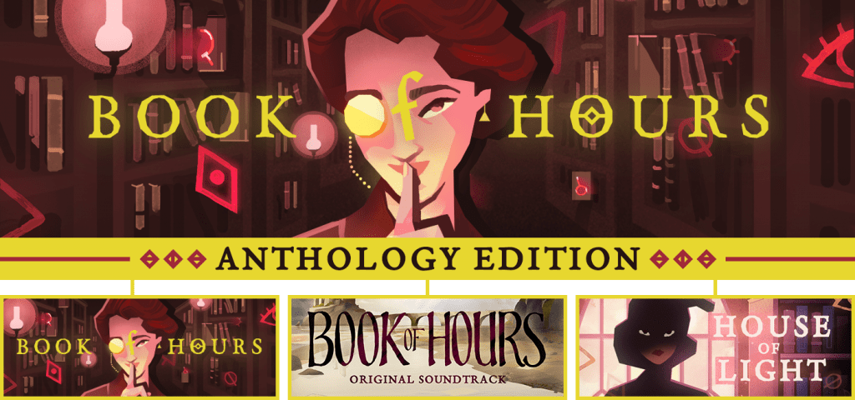

**About HOUSE OF LIGHT**

*“Europe, 1937. The War in the World is coming, and worse yet, the War in the Sun. In this gathering gloom, the notables of the occult underworld consider new weapons; new alliances; new paths. Who can they turn to for help, if not the Librarian of Hush House?*

*Explore visitors and their stories in much greater depth. Host exotic feasts and sophisticated soirées. And in your own quiet way, shape the genesis of the controversial Lighthouse Institute.”*

Key features of the HOUSE OF LIGHT expansion include:

* **FOOD -** combine Ingredients, Sustenance, and Kitchenware items at the three Kitchen workstations to create nearly a hundred new dishes.
* **A WRITING-CASE -** once you've received this gift, you can record addresses from the calling-cards left by satisfied visitors; and write to these visitors to invite them back to the House.
* **SALONS -** place food and drink in one of the six Salon rooms, and then use the bell to begin a Salon. Do it right and you'll be rewarded with sparkling conversation... and Lessons.
* **MANUSCRIPTS -** use Paper, Ink, and a Skill to write a Manuscript based on that skill. These Manuscripts may be necessary to satisfy thirsts for *specific* knowledge in FURTHER STORIES. Lessons from Salons will help you improve those Skills and write more useful Manuscripts.
* **FURTHER STORIES -** once you've completed an Incident, follow it up in the Tree of Wisdoms. Visitors will need more specific help here - perhaps a book on a specific topic, or a specific book.
* **THE INSTITUTE** **-** look for the lighthouse, out at sea. When your Visitors are ready, use it to establish the true heirs to the Curia of the Isle.

**Assets**

* Press kit - <https://weatherfactory.biz/book-of-hours-streamer-press-kit/>
* Store pages: [Steam](https://store.steampowered.com/app/2834350/BOOK_OF_HOURS_HOUSE_OF_LIGHT/), [GOG](https://www.gog.com/en/game/book_of_hours_house_of_light)

**About BOOK OF HOURS**

*“Shutter the windows against the sea. Bank the fire against the cold. Listen to the rain rattle on the roof, while you slide books one by one into their ancient nests…”*

For fifteen centuries, Hush House was a fortress of knowledge. Until the fire. The collection is ruined, and the last Librarian is gone. Only one with your unique talents can rebuild the library, and uncover its mysteries.

Enjoy the sweet peace of organising books and customising your new home, all while unpeeling centuries of history from the occult stones around you. As the newest Librarian, you've chosen solitude... but your influence extends far beyond the walls of Hush House. It's up to you to determine how history is written.

*BOOK OF HOURS* is an elegant, melancholy, combat-free crafting RPG set in an occult library, from the creator of *Fallen London*, *Sunless Sea* and the double BAFTA-nominated *Cultist Simulator*.

**About Weather Factory**

Weather Factory was co-founded in 2017 by Alexis Kennedy and Lottie Bevan to make ingenious narrative games with a consciously indie aesthetic. The teeny two-person studio released double-BAFTA-nominated *Cultist Simulator*, luxury Lovecraftian TRPG *The Lady Afterwards*, and narrative RPG *BOOK OF HOURS*. They are currently in pre-production on a third game, yet to be announced.

[Twitter](https://twitter.com/factoryweather) / [Facebook](https://www.facebook.com/BOOKOFHOURSGAME/) / [Instagram](https://www.instagram.com/weatherfactory/) / [YouTube](http://youtube.com/@weatherfactory)

**Contact Information**

For more information or review keys, please contact:

Lottie Bevan - Co-Founder, Weather Factory

[lottie@weatherfactory.biz](mailto:lottie@weatherfactory.biz) / 07795 006246