Whisper of the House: Cozy Organizing Meets Enchanting Secrets in New Steam Demo



**June 2025** – Get ready to declutter, decorate, and maybe even dabble in a little time travel!

The charming pixel-art organizing and decorating game, **Whisper of the House**, has entered its final development phase. To give players an immediate glimpse into its unique blend of cozy gameplay and intriguing secrets, a **free demo is now available on Steam.**

In *Whisper of the House*, players step into the shoes of a humble housekeeper in the quaint **Whisper Town**. What starts as a seemingly normal job of unpacking, organizing, and decorating homes quickly blossoms into something much more whimsical, packed with delightful hidden interactions and even subtle time-bending adventures.

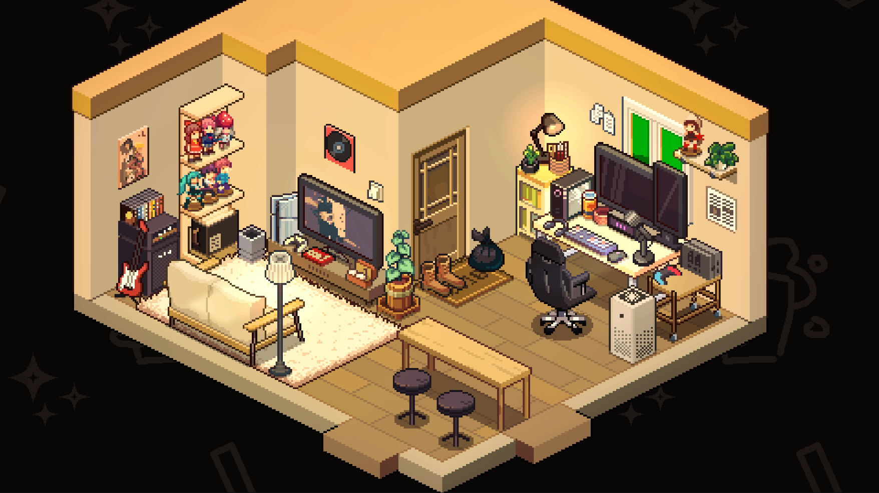

**Unpack, Organize, and Explore the vibrant locale**

The demo gives players a taste of the core gameplay, where they team up with a trusty robot sidekick, **Mark**, to tackle various household tasks.

From arranging furniture and tidying up cluttered spaces to discovering charming little secrets, every click brings players closer to transforming a messy room into a masterpiece.

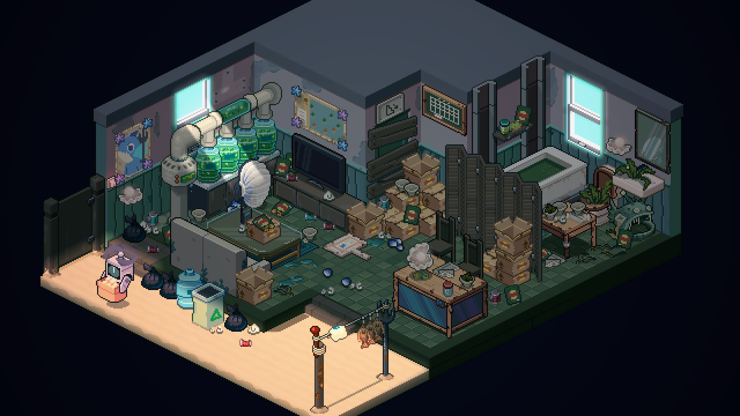

This vibrant locale is brimming with delightful details and hidden interactions. Take a moment to interact with the local environment, discover charming town secrets, or even use your hard-earned rewards to furnish your own cozy home. The town is yours to explore and enjoy.

**More Than Just Tidying Up**

Beyond the satisfying act of organization, *Whisper of the House* weaves in engaging narratives and delightful surprises. Players will meet a diverse cast of town residents, each with their own unique quirks and secrets. Careful arrangement of their spaces might even alter their lives in unexpected ways!



"Things then get weird. My next job involves an old man’s house but surprise — there’s a mad scientist’s lab underneath it. I end up time traveling back to the past, and have to tidy up the old man’s house," shared a reviewer, highlighting the game's charmingly eccentric twists.

**Key Features:**

* **Cozy Pixel Art & Soothing Soundtrack:** Immerse yourself in the calming world of Whisper Town.
* **Satisfying Organizing Gameplay:** Unpack, arrange, and decorate with thousands of unique, interactive furniture items.
* **Hidden Interactions & Secrets:** Discover charming details, from tickling a sleeping cat to uncovering surprising storylines.
* **Engaging Character Stories:** Help the townsfolk with their unique requests and uncover their hidden tales.
* **Personalized Home Decor:** Earn new furniture and decorate your own cozy home.
* **Photo Mode:** Capture and share your beautifully organized creations with friends.

Don't miss the chance to get a sneak peek at the delightful world of *Whisper of the House*. The **free demo is available now on Steam** at<https://store.steampowered.com/app/2589500/_/>.

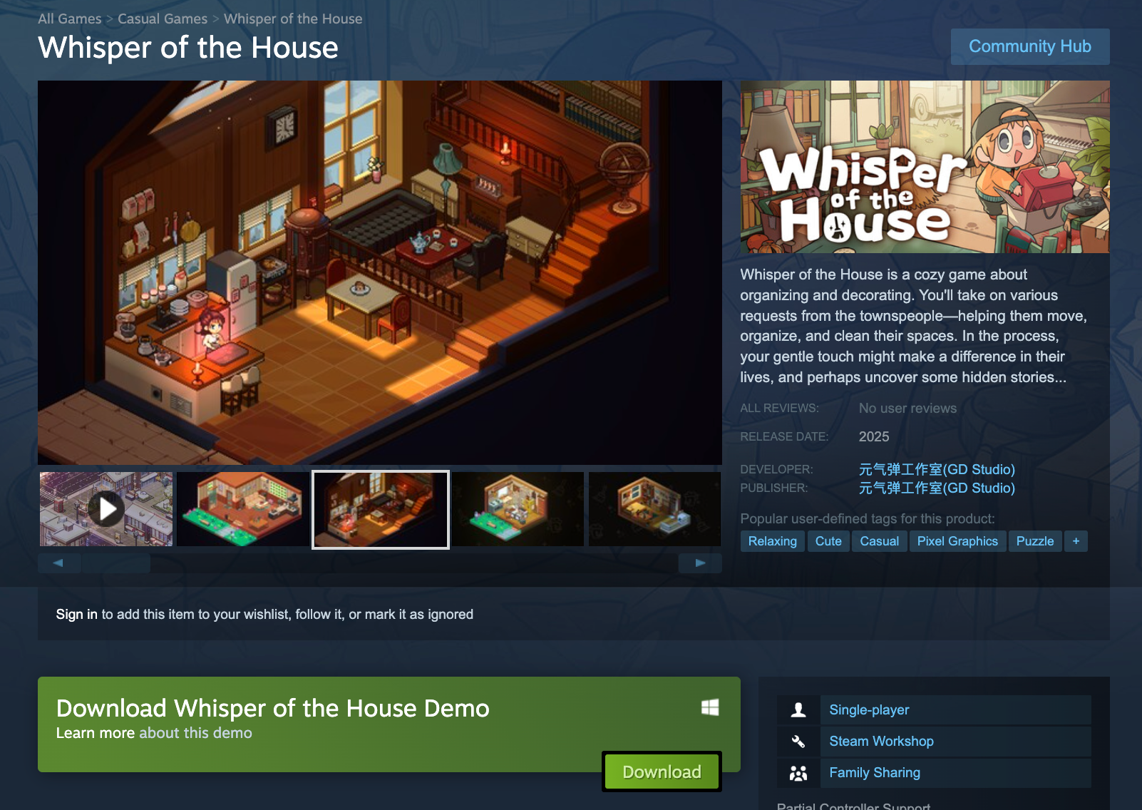

**About GD Studio :**

Founded in 2022 by a team of passionate developers, GD Studio is an independent game studio driven by the belief that games possess the unique power to tell compelling stories, foster connections, and push the boundaries of interactive entertainment.

Press kit is available [here.](https://drive.google.com/drive/folders/10K7u7dZs09biihK-iOJ6jnISoCd6C14a?usp=drive_link)

[Demo is available on Steam](https://store.steampowered.com/app/2595130/_Demo/)

**Socials**

[GD Studio Website](https://shgdstudio.com/) ｜[YouTube](https://www.youtube.com/@WhisperoftheHouse) ｜ [X](https://x.com/GD_whisperrr)

**Media Contact:** press@theloonggate.com